Nicholas Payton and Butcher Brown
A SUPREME BLUE

Two of the Greatest Albums Ever Made, as You've Never Heard Them

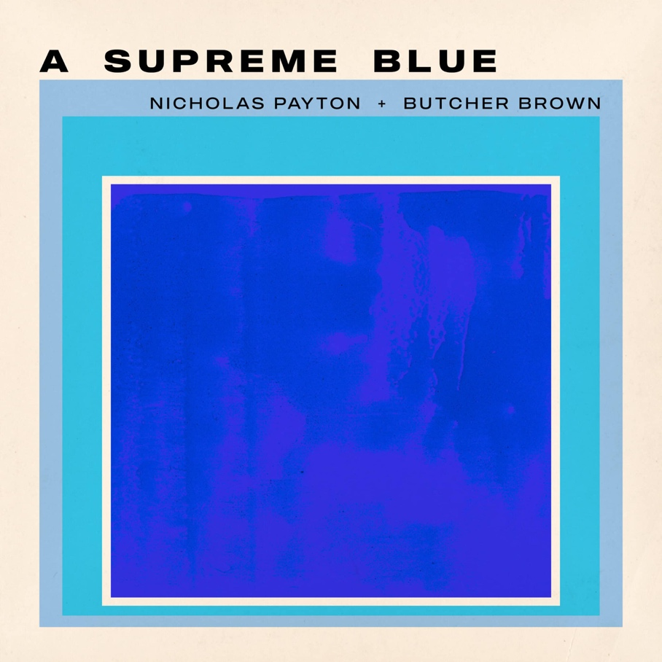

Out digitally July 24 and on vinyl August 14 via Concord Jazz

New single "Pursuance" available now: Listen / Watch

Album pre-order/save

See previously released performance video “All Blues” here

GRAMMY Award-winning multi-instrumentalist, producer, and arranger Nicholas Payton teams up with Virginia-bred collective Butcher Brown for A Supreme Blue, a bold and deeply considered reimagining of two of the most revered albums in recorded music, Miles Davis's Kind of Blue (1959) and John Coltrane's A Love Supreme (1965). Created in honor of the centennial year of both Davis and Coltrane, the album arrives digitally July 24 on Concord Jazz with vinyl release to follow on August 14. The second track, "Pursuance," is available now.

The project was born from a single unplanned moment at a Butcher Brown show, when Payton sat in over the band's House-inflected groove and began quoting the opening theme of Coltrane's "Acknowledgement." Something locked in. By that night's end, the text had gone out from Payton to drummer Corey Fonville: "Yo man, we gotta do a record." The Instagram clip from the evening was hashtagged #AHouseSupreme. The concept followed.

Payton and Fonville go back to 2010, when Fonville was a student at the Brubeck Institute and Payton was Artist-in-Residence. The New Orleans music master immediately recognized Fonville's rare dual fluency, swinging and groove-playing with equal authority. Their creative relationship deepened across years of collaboration, Payton serving as mentor, co-conspirator, and champion as Butcher Brown came into their own, making A Supreme Blue the natural culmination of that long arc. The Richmond-formed collective comprises Corey Fonville (drums, percussion) DJ Harrison (keyboards, piano, percussion), Marcus "Tennishu" Tenney (tenor saxophone, vocals), Morgan Burrs (guitar, MPC), and Andrew Randazzo a/k/a R4ND4ZZO (bass guitar, synth bass).

The centennial frame gave the project its purpose; the rhythmic argument gave it its architecture. Payton heard the connection immediately: both albums share a modal approach, a spiritual component, and a foundational African rhythmic conception, the percussive Mozambique groove threading through "Acknowledgement," Elvin Jones's drumming rooted in an African musical sensibility. Those elements, refracted through House music's pulse, became the album's engine.

Sessions at Spacebomb Studios in Richmond proceeded with minimal preparation and no rehearsal, by design. Tracks emerged organically from the room itself. 'Pursuance,' the single out today, is characteristic: R4ND4ZZO arrived at a bass line, the group fell in, and Payton, who arranged the track, called for tape. Tennishu took the tenor, and with no keyboards present, the track assumed a darker quality no one had anticipated thirty minutes before. The whole album unfolded this way.

Recording and mix engineer Alex de Jong proved integral to the album's identity, adding dub-influenced effects in real time during tracking, a process that shaped how the musicians played, not just how the record sounds. Listening back to the mixes, Fonville said simply: “King Tubby would be proud.”

Liner notes for A Supreme Blue are written by Ashley Kahn, author of both Kind of Blue: The Making of the Miles Davis Masterpiece and A Love Supreme: The Story of John Coltrane's Signature Album, making him a rare voice capable of fully contextualizing what Payton and Butcher Brown have achieved here. The album was mastered by Michael Fossenkemper at Turtletone Studios, with photography by Ryan Gary of The Sunroom and package design by Jamie Breiwick. The album will be available digitally and as a 2-LP limited edition of 1,500 worldwide in standard black vinyl.

A Supreme Blue is not a tribute record. It is an act of creative faith in the source material, in the musicians, and in the music's capacity to go where it wants to go. "This is fresh," Fonville says. "I think they would have appreciated hearing their music in this way, and not hearing it still being played the way they did it in 1959 or 1963. It's 2026."

TRACKLIST
1. So What (Miles Davis)
2. Freddie Freeloader (Miles Davis)
3. Blue in Green (Miles Davis)
4. All Blues (Miles Davis)
5. Flamenco Sketches (Miles Davis)
6. Acknowledgement (John Coltrane)
7. Resolution (John Coltrane)
8. Pursuance (John Coltrane)
9. Psalm (John Coltrane)

TOUR DATES
June 29 — Montreal, QC | Le Festival International de Jazz de Montreal
August 14 — Sardinia, Italy | Time In Jazz

PERSONNEL
Nicholas Payton: Trumpet, Rhodes, Piano, Vocoder, Vocals, Thumb Piano
Tennishu: Tenor Saxophone
Morgan Burrs: Guitar
DJ Harrison: Keyboards, Melodica, Guitar
R4ND4ZZO: Bass Guitar, Synth Bass
Corey Fonville: Drums, Percussion

Conceptualized by Nicholas Payton
Produced by Nicholas Payton and Butcher Brown

About Nicholas Payton
Nicholas Payton is a New Orleans-born GRAMMY Award-winning trumpet virtuoso, multi-instrumentalist, producer, and arranger whose career spans more than three decades across swing, funk, R&B, and the avant-garde. A singular force in Black American music, Payton has consistently repositioned himself at the intersection of tradition and innovation across a catalog of acclaimed recordings and performances.
nicholaspayton.com

About Butcher Brown
Butcher Brown is a Richmond, Virginia-based collective formed in 2009 whose music draws on jazz, hip-hop, funk, and electronic music in equal measure. Comprising DJ Harrison, Marcus "Tennishu" Tenney, Morgan Burrs, R4ND4ZZO, and Corey Fonville, the band has built a devoted following through relentless touring and a series of critically lauded recordings, earning a reputation as one of the most creatively restless ensembles in contemporary music.
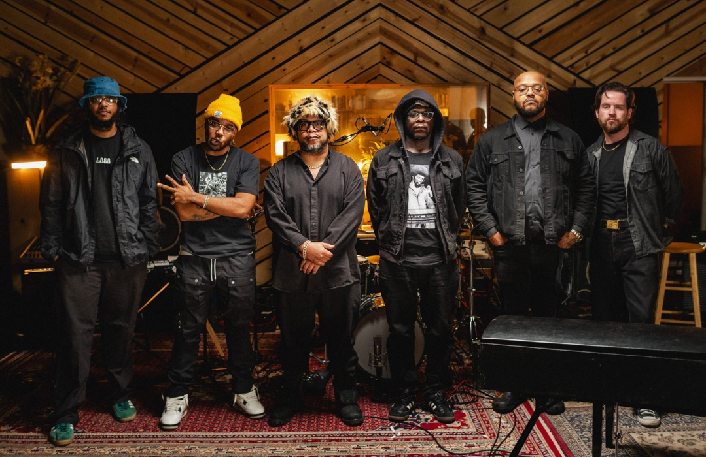

Butcher Brown Online
Website
Spotify
Instagram
Facebook
YouTube
TikTok
X

Nicholas Payton Online
Website
Spotify
Soundcloud
YouTube
TikTok
X

Chart Room Media
brendan@chartroommedia.com | chartroommedia.com | 347-450-3048

