Nicholas Payton and Butcher Brown
A SUPREME BLUE
Two of the Greatest Albums Ever Made, as You’ve Never Heard Them
Out digitally July 24 and on vinyl August 14 via Concord Jazz

New single “Blue In Green” available now: Listen / Watch
Album pre-order/save

Previously released performance videos:
“All Blues”
“Resolution”

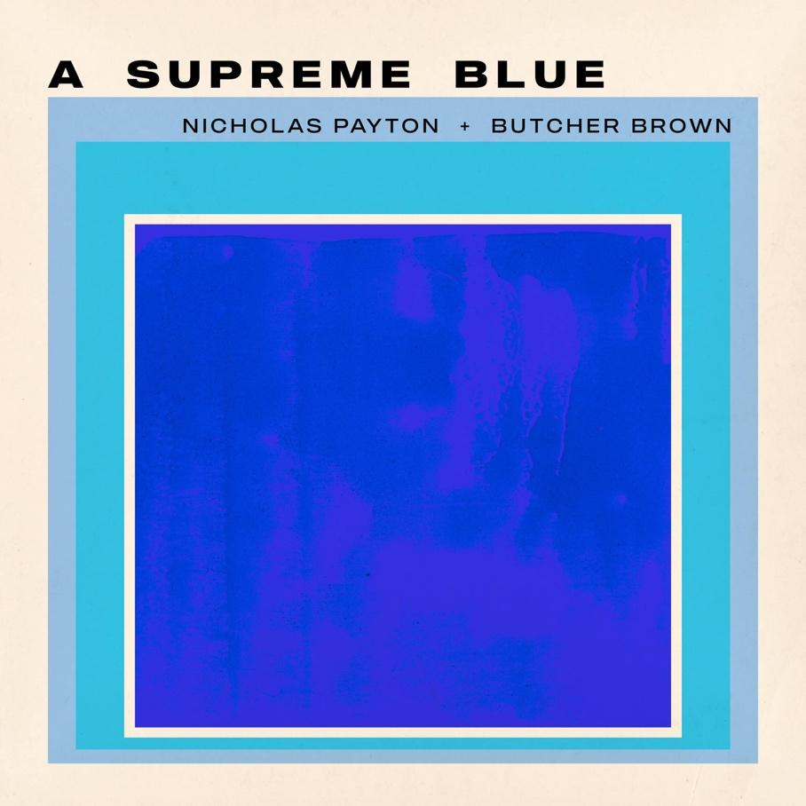

Nicholas Payton & Butcher Brown have released "Blue In Green," the latest single from their forthcoming collaborative album A Supreme Blue, due July 24 on Concord Jazz (vinyl out August 14).
The track arrives alongside a performance video and continues the pair's reimagining of Miles Davis's Kind of Blue and John Coltrane's A Love Supreme, two of the most revered albums in American music history, through the lens of House, dub, and the Black American musical tradition.
“We ended up pulling from so many vibes in the process of reimagining these classics. When it came time to treat ‘Blue In Green’ my mind immediately went to Daft Punk’s ‘Nightvision’. I suggested we go for that vibe and it just clicked. The airy pads and hypnotic drum groove set the mood perfectly for a modern day ballad.” -- R4ND4ZZO, Butcher Brown

TRACKLIST
1. So What (Miles Davis)
2. Freddie Freeloader (Miles Davis)
3. Blue in Green (Miles Davis)
4. All Blues (Miles Davis)
5. Flamenco Sketches (Miles Davis)
6. Acknowledgement (John Coltrane)
7. Resolution (John Coltrane)
8. Pursuance (John Coltrane)
9. Psalm (John Coltrane)

TOUR DATES
June 29 — Montreal, QC | Le Festival International de Jazz de Montréal
August 14 — Sardinia, Italy | Time In Jazz
PERSONNEL
Nicholas Payton: Trumpet, Rhodes, Piano, Vocoder, Vocals, Thumb Piano
Tennishu: Tenor Saxophone
Morgan Burrs: Guitar
DJ Harrison: Keyboards, Melodica, Guitar
R4ND4ZZO: Bass Guitar, Synth Bass
Corey Fonville: Drums, Percussion

Conceptualized by Nicholas Payton
Produced by Nicholas Payton and Butcher Brown
About Nicholas Payton
Nicholas Payton is a New Orleans-born GRAMMY Award-winning trumpet virtuoso, multi-instrumentalist, producer, and arranger whose career spans more than three decades across swing, funk, R&B, and the avant-garde. A singular force in Black American music, Payton has consistently repositioned himself at the intersection of tradition and innovation across a catalog of acclaimed recordings and performances.
About Butcher Brown
Butcher Brown is a Richmond, Virginia-based collective formed in 2009 whose music draws on jazz, hip-hop, funk, and electronic music in equal measure. Comprising DJ Harrison, Marcus “Tennishu” Tenney, Morgan Burrs, R4ND4ZZO, and Corey Fonville, the band has built a devoted following through relentless touring and a series of critically lauded recordings, earning a reputation as one of the most creatively restless ensembles in contemporary music.

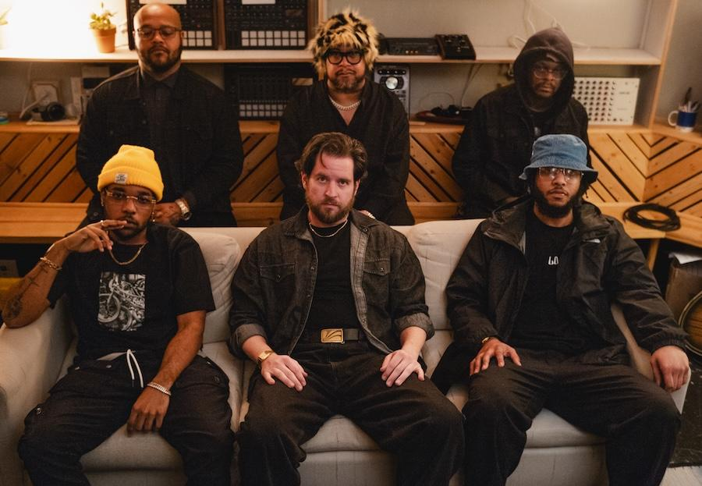

Butcher Brown Online
Website
Spotify
Instagram
Facebook
YouTube
TikTok
X
Nicholas Payton Online
Website
Spotify
Soundcloud
YouTube
TikTok
X
Chart Room Media
brendan@chartroommedia.com | chartroommedia.com | 347-450-3048

