Keb’ Mo’ Strips It Back To Just His Voice and Guitar on New Album The Breakdown
out August 21 via Concord Records

Official Performance Video For New Single
“Fussing and Fighting” Out Now

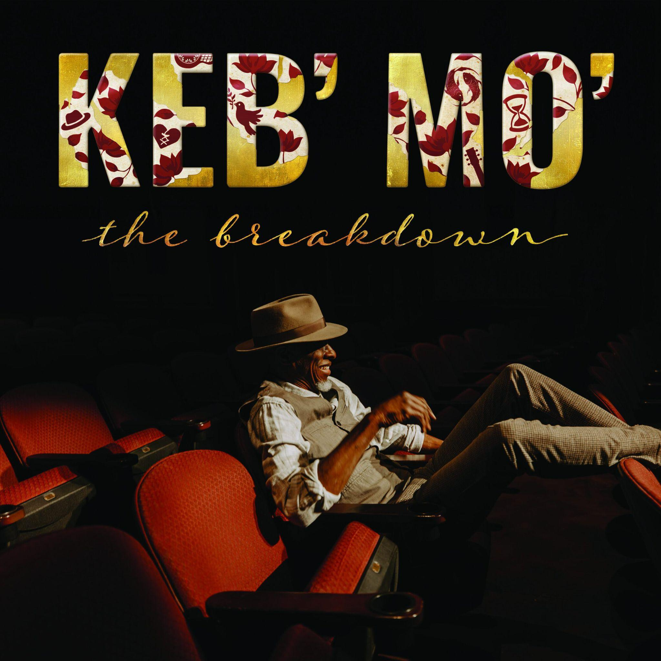
Download Album Artwork

June 5, 2026 – More than 50 years into a career marked by five GRAMMY wins, an Americana Music Association Lifetime Achievement Award, performances everywhere from Carnegie Hall to The White House, and songs recorded by everyone from B.B. King to BTS, Keb’ Mo’ returns with his most stripped-down and intimate album to date. On The Breakdown, out August 21 via Concord Records, he does something he has never done before: strips back his recordings to just his guitar, voice and carefully selected vocal contributions from the Soweto Gospel Choir and the gospel sextet Take 6.

The 10-song collection was recorded at his home studio outside Nashville and written in the wake of life-saving open heart surgery, the end of his nearly 20-year marriage, and a period of profound personal upheaval. Stark and deeply honest, The Breakdown is Keb’ at his most revealing, grappling with the passage of time and the inevitability of change while still holding on firmly to the hope, faith, and love that have always guided him.

“It felt like everything in my life was breaking down,” Keb’ reflects. “My health, my relationship, my whole world. The only way I knew how to respond was to break the music down, too.”

While the album is deeply rooted in Keb’s personal story, the tunes also stand as broader commentary on the state of the world at large. Today, he released the album’s first single “Fussing and Fighting,” which could just as easily reflect a long-term relationship as a divided nation searching for common ground.

Watch a live performance video of “Fussing and Fighting”
Watch the visualizer for “Fussing and Fighting”
Pre-order The Breakdown

“Fussing and Fighting” sprang from the way relationships can suddenly go south. Sometimes things just don’t work out, and you’re left wondering, “What happened?,” he explains

The Breakdown marks Keb’ Mo’s first solo album release since his GRAMMY-nominated 2021 album Good To Be… and his first since his career nearly came to an abrupt end in 2024 when he began experiencing shortness of breath on tour with Slash. “I was struggling to breathe and thought there must be something wrong with my lungs,” Keb’ recalls. “When I finally got off the road, I went to the doctor, and they sent me straight to the emergency room.”

The problem, it turned out, was not with his lungs, but rather his heart. A leaking valve and aortic aneurysm required intensive surgery, and the lengthy rehabilitation period forced the postponement of a slew of tour dates.

“It felt like death was tapping me on the shoulder,” Keb’ explains. “I’d been going around feeling healthy and strong all these years, and suddenly I had to face the possibility that I might not make it. I had to go through some difficult experiences to get these songs, but I learned a lot looking back on my life and my relationships and taking inventory of everything in a new light.”

That newfound perspective is front and center on The Breakdown, which manages to turn pain and uncertainty into hope and resilience at every turn. “I’m turning 75 this year,” Keb’ reflects, “and I know I won’t be around forever. All you can do is make the most of what you’ve got and be grateful for every step of the journey.”

The Breakdown:
01) Fussing and Fighting
02) Every Step of the Way
03) They Don’t Make ‘Em Like They Used To (feat. Take 6)

04) More Yesterdays
05) We Make Love
06) Walking on Water
07) Hand It Over (feat. Soweto Gospel Choir)
08) Living in the Moment
09) Stitched Up Heart
10) One Day Away

Keb’ Mo’ Solo Tour Dates:
06/08 – Dublin, Ireland – National Concert Hall
06/10 – London, United Kingdom – Union Chapel
06/12 – Paris, France – Bataclan
06/13 – Leuven, Belgium – Het Depot
06/15 – Mannheim, Germany – Alte Feuerwache
06/16 – Zurich, Switzerland – Kaufleuten
06/17 – Bern, Switzerland – Bierhübeli
06/19 – Bremen, Germany – Kulturzentrum Schlachthof
06/20 – Grolloo, Netherlands – Holland International Blues Festival
06/22 – Leipzig, Germany – Anker Connewitz
06/23 – Braunschweig, Germany – Schon & Frohlich
06/24 – Bochum, Germany – Christuskirche
06/26 – Vejle, Denmark – Vejle Musikteater
06/27 – Copenhagen, Denmark – DR Koncerthuset (DR Concert Hall)
01/09 – 01/15 – Fort Lauderdale, FL – Sandy Beaches Cruise 2027 (full band)
01/16 – 01/23 – Fort Lauderdale, FL – The Big Easy Cruise 2027 (full band)
01/31 – 02/7 – Ft Lauderdale, FL – Legendary Rhythm and Blues Cruise

Follow Keb’ Mo’:
Website - Facebook - Instagram - Twitter
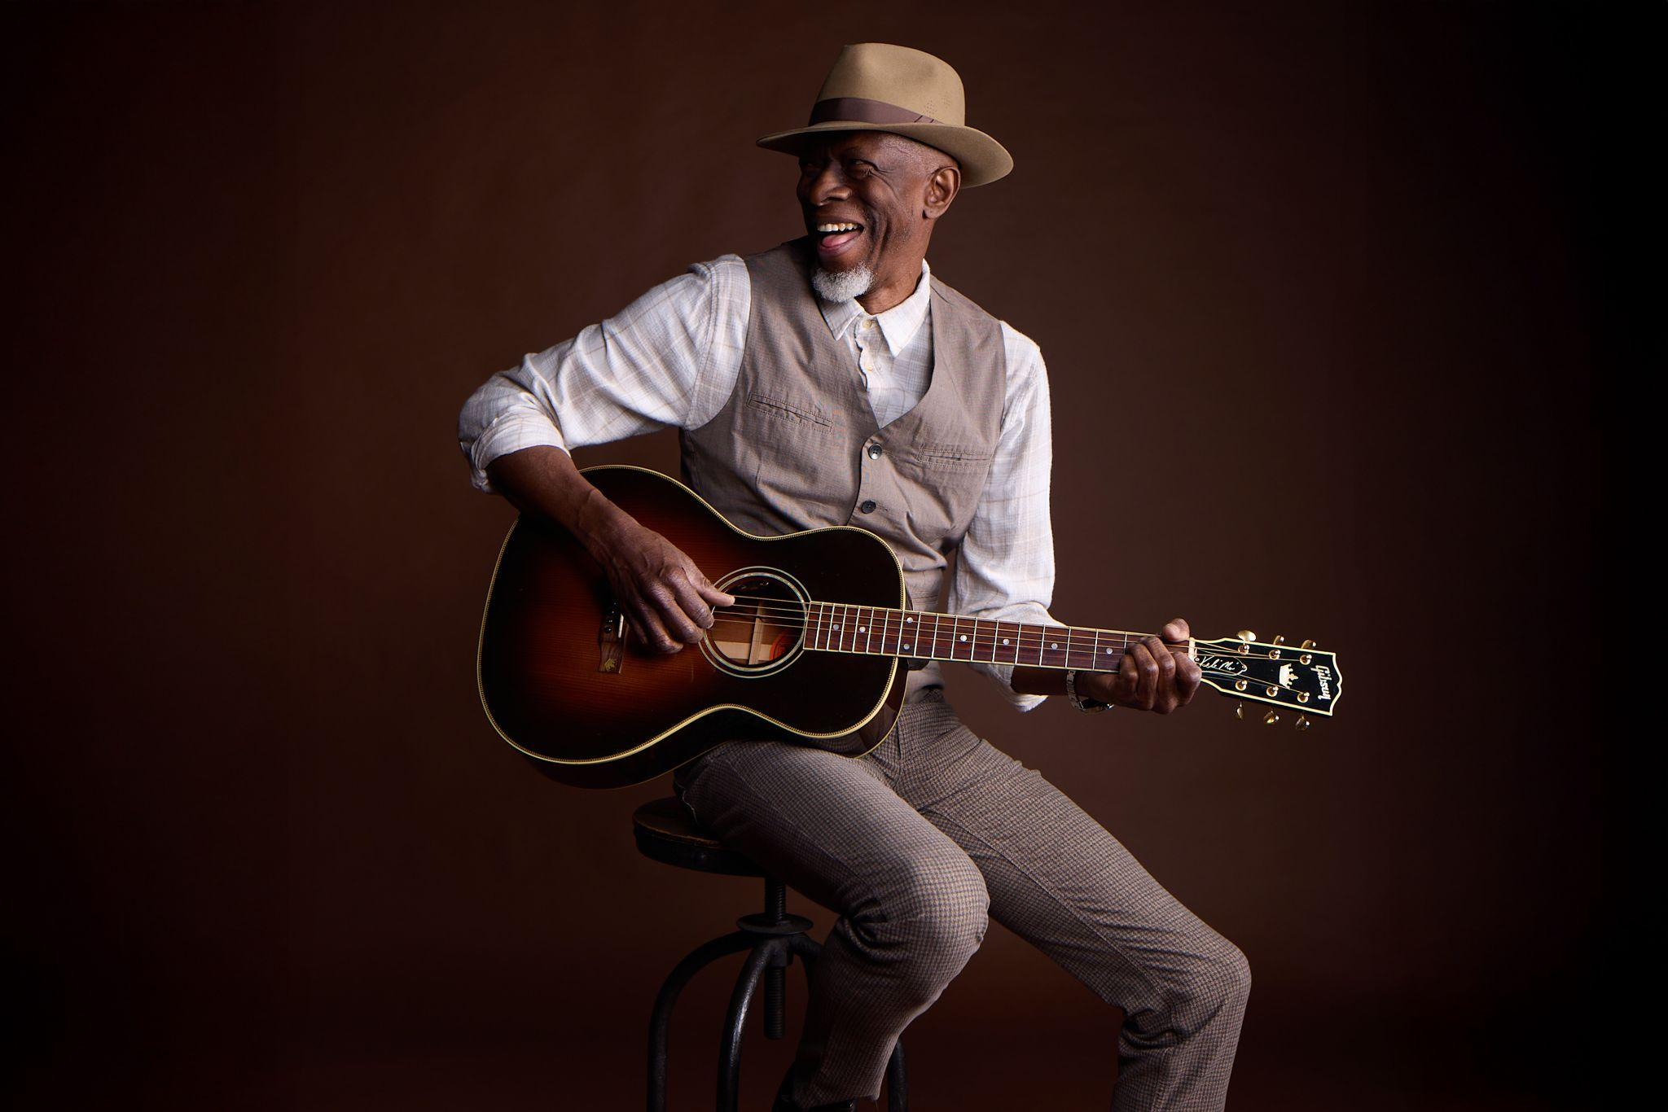
Download Photo / Credit: Rachel Deeb
For more information, please contact:
Joe Sivick (joe@missingpiecegroup.com)
Brett Loeb (brett@missingpiecegroup.com)
at Missing Piece Group

