

Keb’ Mo’ Releases New Single “Hand It Over” Featuring the Soweto Gospel Choir

New Album The Breakdown
out August 21 via Concord Records
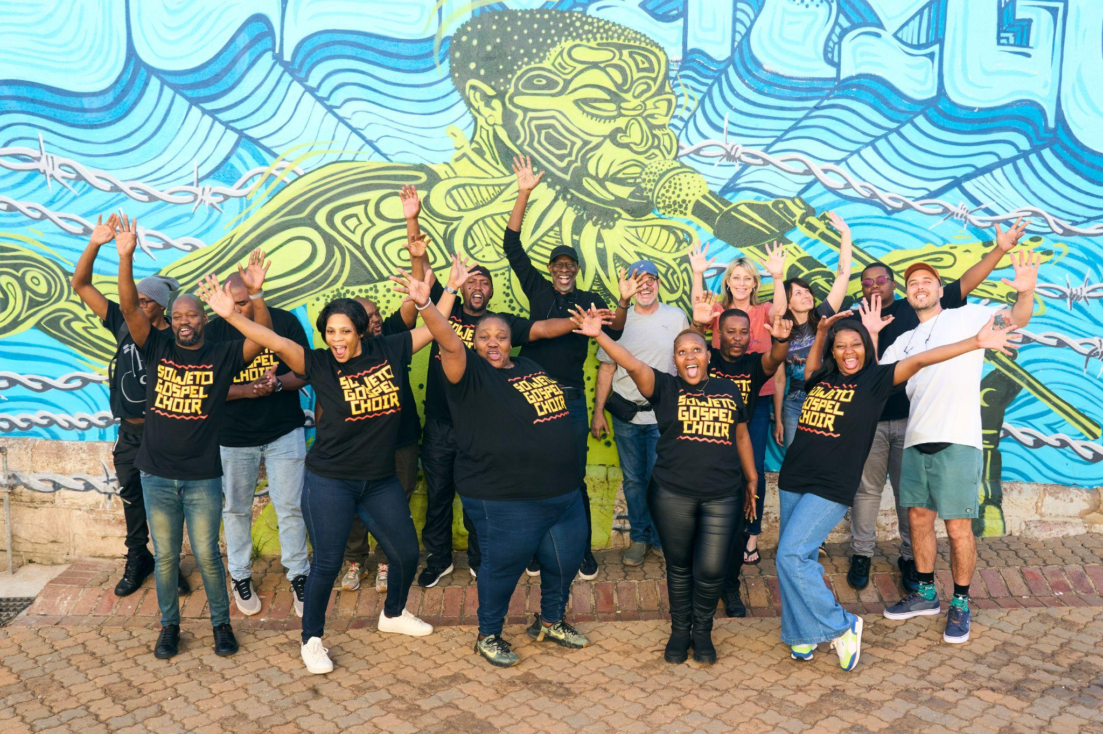
Keb’ Mo’ with the Soweto Gospel Choir
Download Photo / Credit: Ray Manzana
June 24, 2026 – Today, 5x GRAMMY-winner Keb’ Mo’ released “Hand It Over” featuring the Soweto Gospel Choir from his forthcoming album The Breakdown that will be released on August 21 via Concord Records. Originally appearing on his 1996 GRAMMY-winning album Just Like You, the reimagined version of “Hand It Over” was recorded at Flame Studios in Johannesburg, South Africa, which is housed in a former prison where Nelson Mandela was held during the Rivonia Trial.
Watch the visualizer for “Hand It Over” (feat. Soweto Gospel Choir)
Pre-order The Breakdown
About the song, Keb’ Mo’ explains, “I’m excited to share my collaboration with the Soweto Gospel Choir. Recorded at Flame Studio in Johannesburg, South Africa. Once again, I’m makin’ my mama proud by performing her favorite song of mine. And thank you to the SGC for going on this journey with me!”
“Hand It Over” was recorded just months before his career nearly came to an abrupt end in 2024 when he began experiencing shortness of breath on tour and was admitted to the hospital for a life-saving open heart surgery. The 10-song collection was recorded at his home studio outside Nashville during a period of profound personal upheaval as he recovered from the surgery and also grappled with the dissolution of his nearly 20-year marriage. Stark and deeply honest, The Breakdown is Keb’ at his most revealing, coming to terms with the passage of time and the inevitability of change while still holding on firmly to the hope, faith, and love that have always guided him.
The new single follows the release of “Fussing and Fighting” that was released earlier this month alongside a live performance video.
“I had to go through some difficult experiences to get these songs,” he confesses, “but I learned a lot looking back on my life and my relationships and taking inventory of everything in a new light.” That newfound perspective is front and center on The Breakdown, which manages to turn pain and uncertainty into hope and resilience at every turn. “I’m turning 75 this year,” Keb’ reflects, “and I know I won’t be around forever. All you can do is make the most of what you’ve got and be grateful for every step of the journey.”
The Breakdown:
01) Fussing and Fighting
02) Every Step of the Way
03) They Don’t Make ‘Em Like They Used To (feat. Take 6)
04) More Yesterdays
05) We Make Love
06) Walking on Water
07) Hand It Over (feat. Soweto Gospel Choir)
08) Living in the Moment
09) Stitched Up Heart
10) One Day Away
Keb’ Mo’ Solo Tour Dates:
06/08 – Dublin, Ireland – National Concert Hall
06/10 – London, United Kingdom – Union Chapel
06/12 – Paris, France – Bataclan
06/13 – Leuven, Belgium – Het Depot
06/15 – Mannheim, Germany – Alte Feuerwache
06/16 – Zurich, Switzerland – Kaufleuten
06/17 – Bern, Switzerland – Bierhübeli
06/19 – Bremen, Germany – Kulturzentrum Schlachthof
06/20 – Grolloo, Netherlands – Holland International Blues Festival
06/22 – Leipzig, Germany – Anker Connewitz
06/23 – Braunschweig, Germany – Schon & Frohlich
06/24 – Bochum, Germany – Christuskirche
06/26 – Vejle, Denmark – Vejle Musikteater
06/27 – Copenhagen, Denmark – DR Koncerthuset (DR Concert Hall)
01/09 – 01/15 – Fort Lauderdale, FL – Sandy Beaches Cruise 2027 (full band)
01/16 – 01/23 – Fort Lauderdale, FL – The Big Easy Cruise 2027 (full band)
01/31 – 02/7 – Ft Lauderdale, FL – Legendary Rhythm and Blues Cruise
Follow Keb’ Mo’:
Website - Facebook - Instagram - Twitter
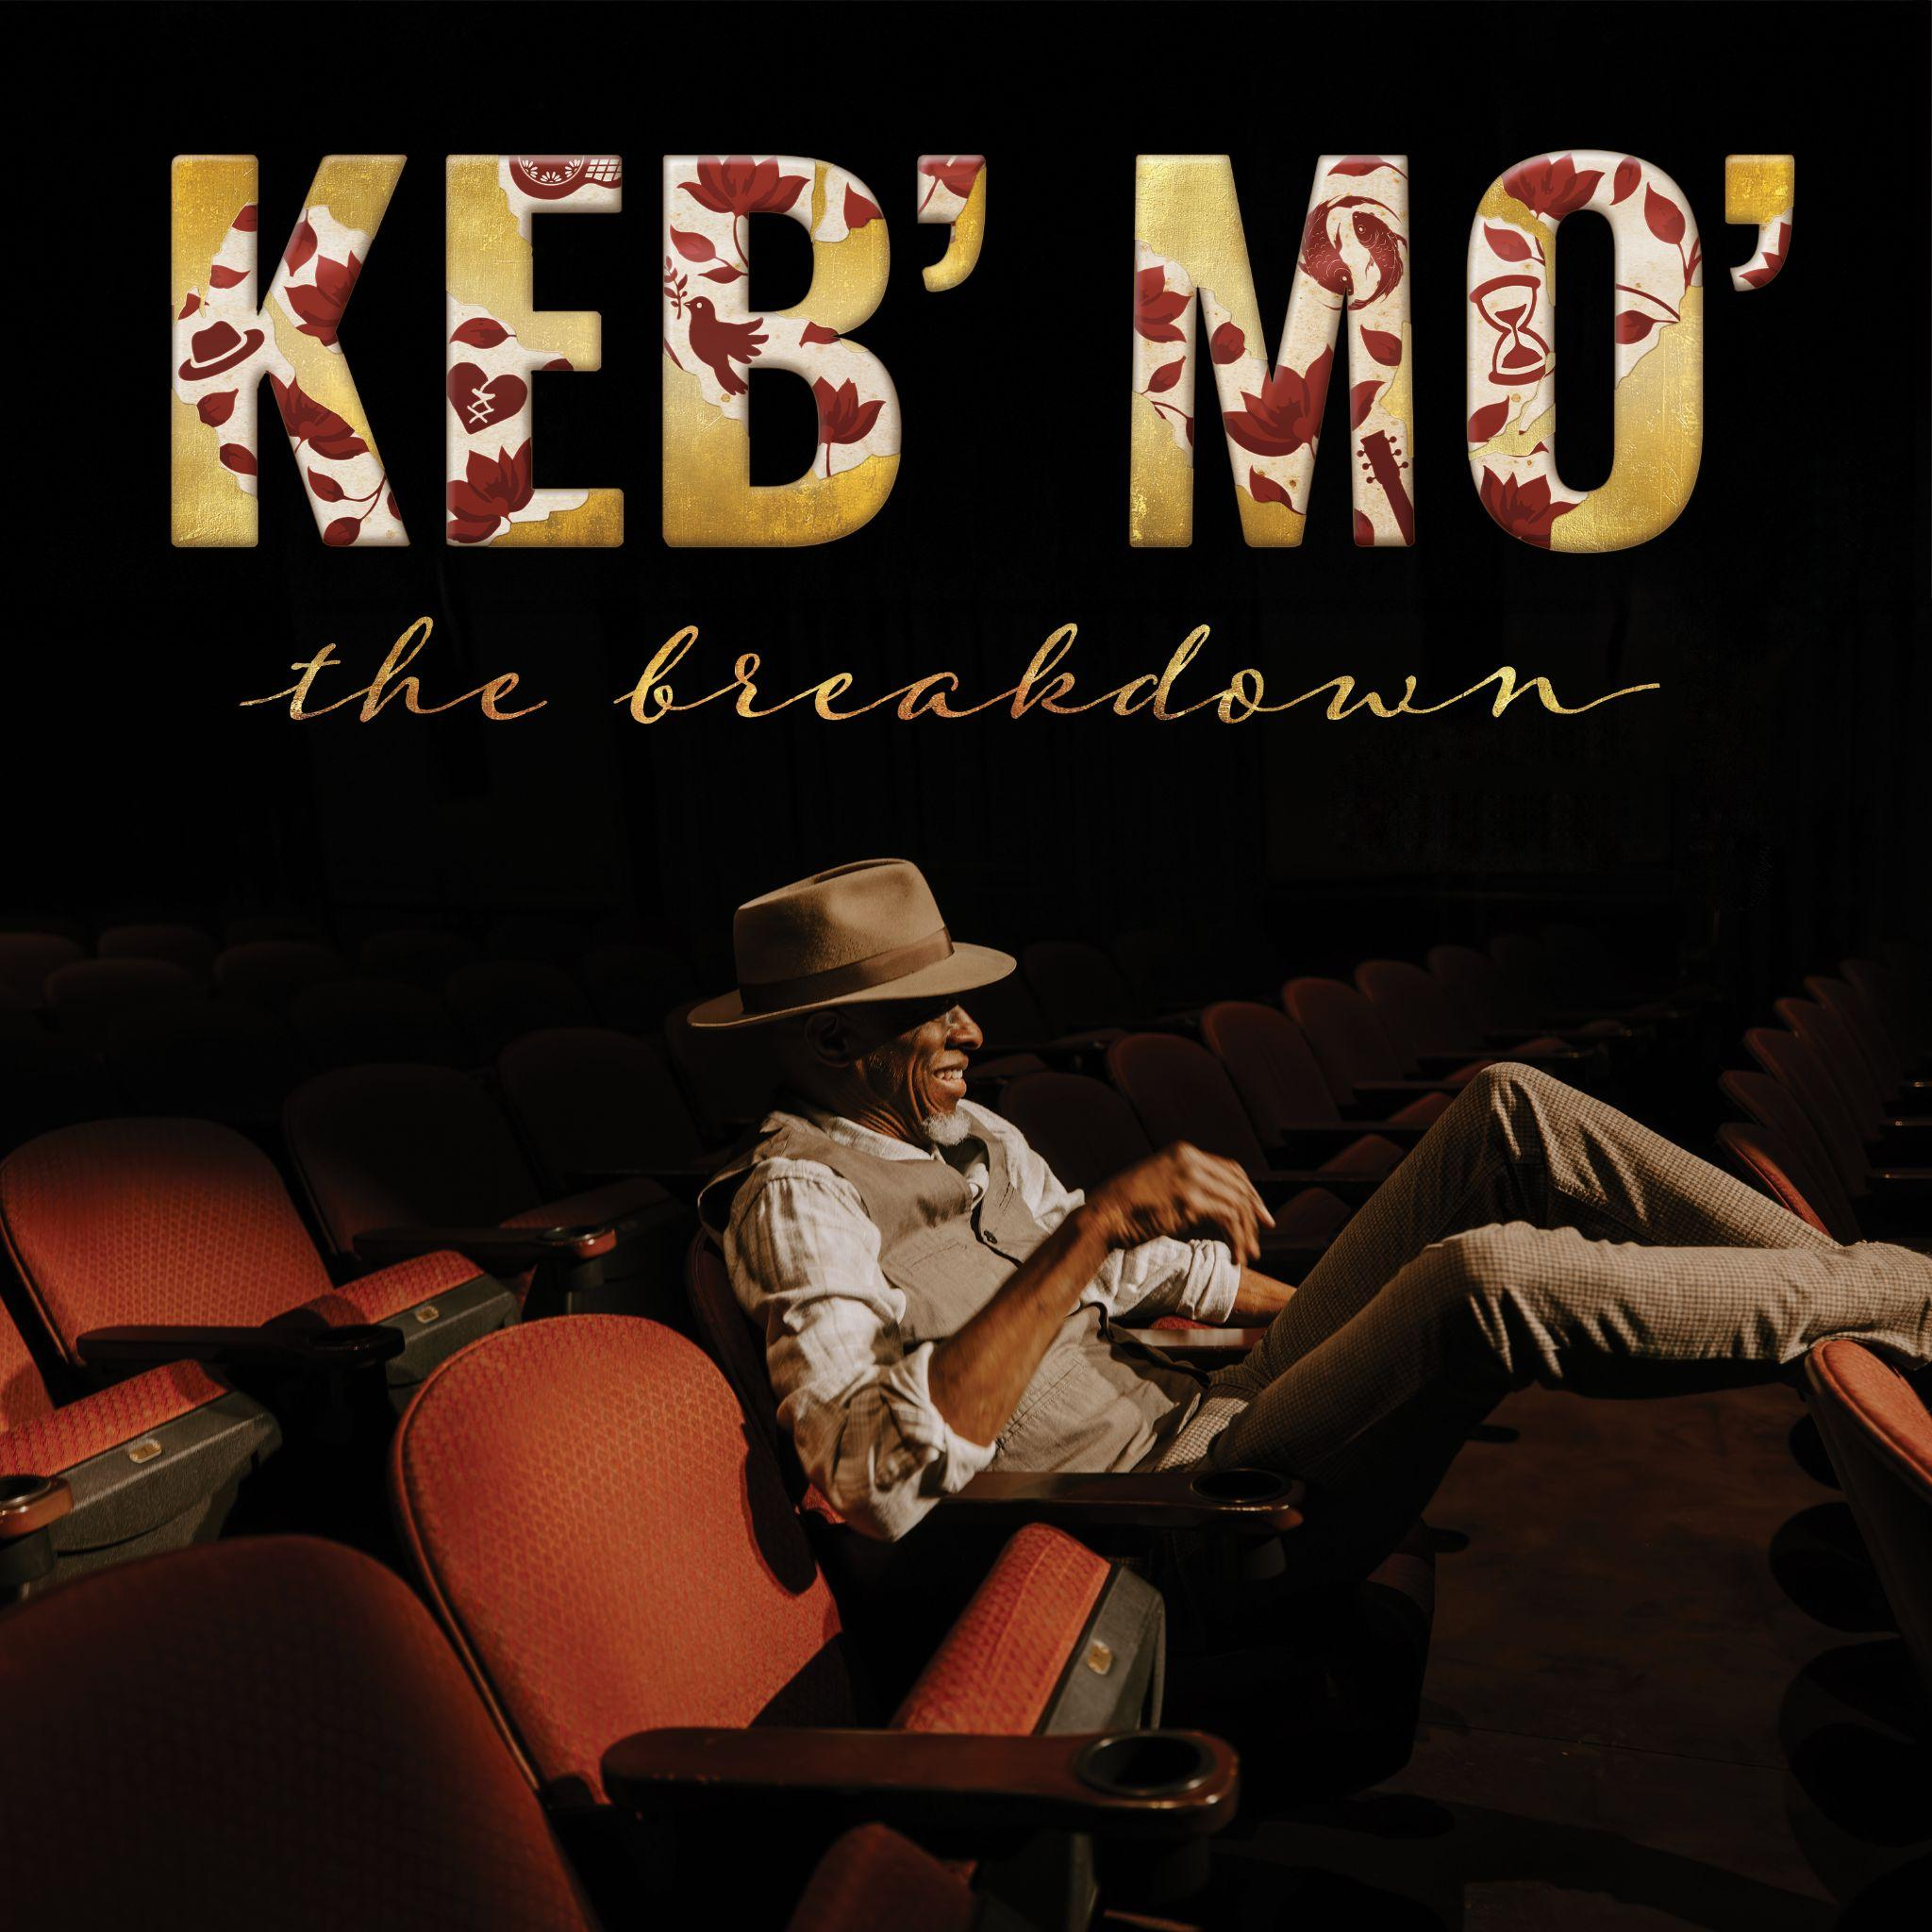
Download Album Artwork

For more information, please contact:
Joe Sivick (joe@missingpiecegroup.com)
Brett Loeb (brett@missingpiecegroup.com)
at Missing Piece Group

