Nicholas Payton and Butcher Brown
A SUPREME BLUE
Two of the Greatest Albums Ever Made, as You’ve Never Heard Them
Out digitally July 24 and on vinyl August 14 via Concord Jazz

New single “Resolution” available now: Listen / Watch
Album pre-order/save
See previously released performance video “All Blues” here

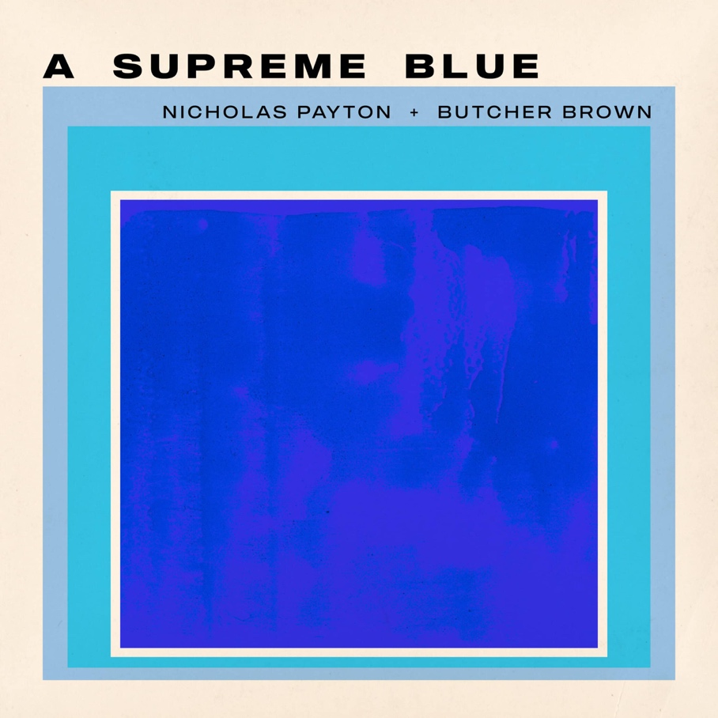

GRAMMY Award-winning multi-instrumentalist, producer, and arranger Nicholas Payton and Richmond-bred collective Butcher Brown share “Resolution,” the new single from their forthcoming album A Supreme Blue, a fearless reimagining of Miles Davis’s Kind of Blue (1959) and John Coltrane’s A Love Supreme (1965), created in honor of the centennial year of both artists. The album arrives July 24 on Concord Jazz with a vinyl release to follow August 14.
“Resolution” is Part II of the A Love Supreme suite. I wrote this arrangement in the hotel the morning before the second session. Jimmy Garrison’s bass intro is so epic and the perfect setup for the tune that I decided to double it between the synth bass and Rhodes to make it super thick. Then I created a vamp that moves through all twelve keys, which becomes the bed for Coltrane’s melody. We solo over the regular chord changes, then vamp out on Garrison’s riff — but I put chords to it to make it sexy.​​​​​​​​​​​​​​​​- Nicholas Payton
“It was an example of us being in the room… we just started grooving out. All the songs. I think we really found creative ways to make each of these songs fresh.” — Corey Fonville

TRACKLIST
1. So What (Miles Davis)
2. Freddie Freeloader (Miles Davis)
3. Blue in Green (Miles Davis)
4. All Blues (Miles Davis)
5. Flamenco Sketches (Miles Davis)
6. Acknowledgement (John Coltrane)
7. Resolution (John Coltrane)
8. Pursuance (John Coltrane)
9. Psalm (John Coltrane)

TOUR DATES
June 29 — Montreal, QC | Le Festival International de Jazz de Montréal
August 14 — Sardinia, Italy | Time In Jazz
PERSONNEL
Nicholas Payton: Trumpet, Rhodes, Piano, Vocoder, Vocals, Thumb Piano
Tennishu: Tenor Saxophone
Morgan Burrs: Guitar
DJ Harrison: Keyboards, Melodica, Guitar
R4ND4ZZO: Bass Guitar, Synth Bass
Corey Fonville: Drums, Percussion

Conceptualized by Nicholas Payton
Produced by Nicholas Payton and Butcher Brown
About Nicholas Payton
Nicholas Payton is a New Orleans-born GRAMMY Award-winning trumpet virtuoso, multi-instrumentalist, producer, and arranger whose career spans more than three decades across swing, funk, R&B, and the avant-garde. A singular force in Black American music, Payton has consistently repositioned himself at the intersection of tradition and innovation across a catalog of acclaimed recordings and performances.
About Butcher Brown
Butcher Brown is a Richmond, Virginia-based collective formed in 2009 whose music draws on jazz, hip-hop, funk, and electronic music in equal measure. Comprising DJ Harrison, Marcus “Tennishu” Tenney, Morgan Burrs, R4ND4ZZO, and Corey Fonville, the band has built a devoted following through relentless touring and a series of critically lauded recordings, earning a reputation as one of the most creatively restless ensembles in contemporary music.

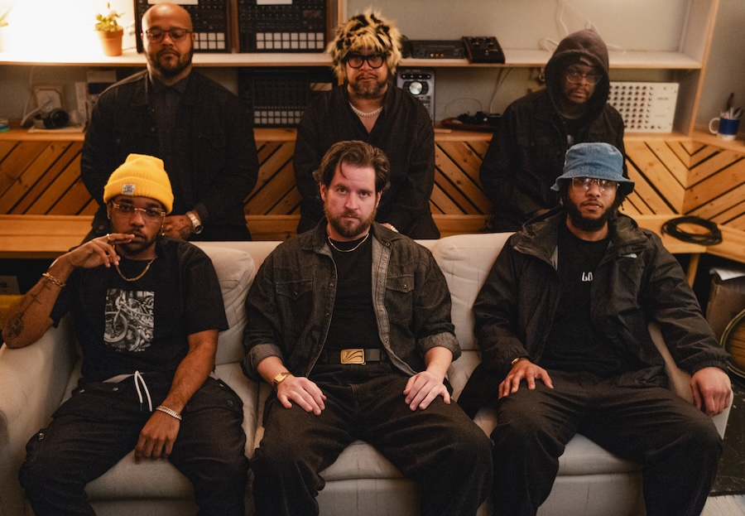

Butcher Brown Online
Website
Spotify
Instagram
Facebook
YouTube
TikTok
X
Nicholas Payton Online
Website
Spotify
Soundcloud
YouTube
TikTok
X
Chart Room Media
brendan@chartroommedia.com | chartroommedia.com | 347-450-3048

