Nicholas Payton and Butcher Brown’s
A SUPREME BLUE
Out Today

Two of the Greatest Albums Ever Made, as You’ve Never Heard Them

Stream/Buy here

Videos “All Blues” and “Resolution”

While many reimaginings by acknowledged innovators end up being overcooked, here we have subtle yet distinctive threads from Coltrane’s A Love Supreme and Davis’s Kind of Blue being woven into a lucid but never overstated fabric of contemporary styles. -- BBC Music Magazine (5/5 Stars)

A fresh, modern sounding record that engages playfully and creatively with the legendary source material...absolutely brilliant. -- Jazzwise (4/5 Stars)

It’s the shared love of these richly spiritual tunes that shines through. -- MOJO (4/5 Stars)

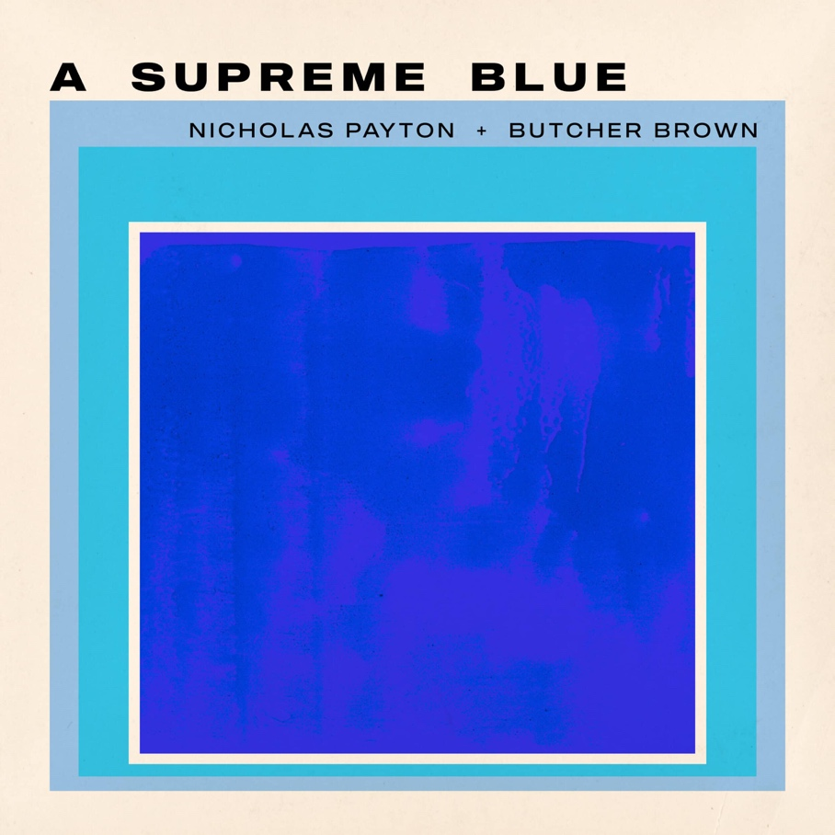

GRAMMY Award-winning multi-instrumentalist, producer, and arranger Nicholas Payton teams up with Virginia-bred collective Butcher Brown for A Supreme Blue, a bold and deeply considered reimagining of two of the most revered albums in recorded music, Miles Davis's Kind of Blue (1959) and John Coltrane's A Love Supreme (1965). Created in honor of the centennial year of both Davis and Coltrane, the album arrives digitally today on Concord Jazz with vinyl release to follow on August 14. The second track, "Pursuance," is available now.

Recorded at Spacebomb Studios in Richmond, Virginia, A Supreme Blue does not position itself as tribute. Payton, in collaboration with Butcher Brown, brings the full weight of his musical voice to a band that meets him at every turn. The album’s rhythmic architecture draws on the modal and spiritual common ground shared by both source records, refracted through the pulse of House music, dub, and the full breadth of the Black American musical tradition.

Liner notes for A Supreme Blue are written by Ashley Kahn, author of both Kind of Blue: The Making of the Miles Davis Masterpiece and A Love Supreme: The Story of John Coltrane's Signature Album, making him a rare voice capable of fully contextualizing what Payton and Butcher Brown have achieved here. The album was mastered by Michael Fossenkemper at Turtletone Studios, with photography by Ryan Gary of The Sunroom and package design by Jamie Breiwick. The album will be available digitally and as a 2-LP limited edition of 1,500 worldwide in standard black vinyl.

TRACKLIST
1. So What (Miles Davis)
2. Freddie Freeloader (Miles Davis)
3. Blue in Green (Miles Davis)
4. All Blues (Miles Davis)
5. Flamenco Sketches (Miles Davis)
6. Acknowledgement (John Coltrane)
7. Resolution (John Coltrane)
8. Pursuance (John Coltrane)
9. Psalm (John Coltrane)

PERSONNEL
Nicholas Payton: Trumpet, Rhodes, Piano, Vocoder, Vocals, Thumb Piano
Tennishu: Tenor Saxophone
Morgan Burrs: Guitar
DJ Harrison: Keyboards, Melodica, Guitar
R4ND4ZZO: Bass Guitar, Synth Bass
Corey Fonville: Drums, Percussion

Conceptualized by Nicholas Payton
Produced by Nicholas Payton and Butcher Brown

About Nicholas Payton
Nicholas Payton is a New Orleans-born GRAMMY Award-winning trumpet virtuoso, multi-instrumentalist, producer, and arranger whose career spans more than three decades across swing, funk, R&B, and the avant-garde. A singular force in Black American music, Payton has consistently repositioned himself at the intersection of tradition and innovation across a catalog of acclaimed recordings and performances.
nicholaspayton.com

About Butcher Brown
Butcher Brown is a Richmond, Virginia-based collective formed in 2009 whose music draws on jazz, hip-hop, funk, and electronic music in equal measure. Comprising DJ Harrison, Marcus "Tennishu" Tenney, Morgan Burrs, R4ND4ZZO, and Corey Fonville, the band has built a devoted following through relentless touring and a series of critically lauded recordings, earning a reputation as one of the most creatively restless ensembles in contemporary music.

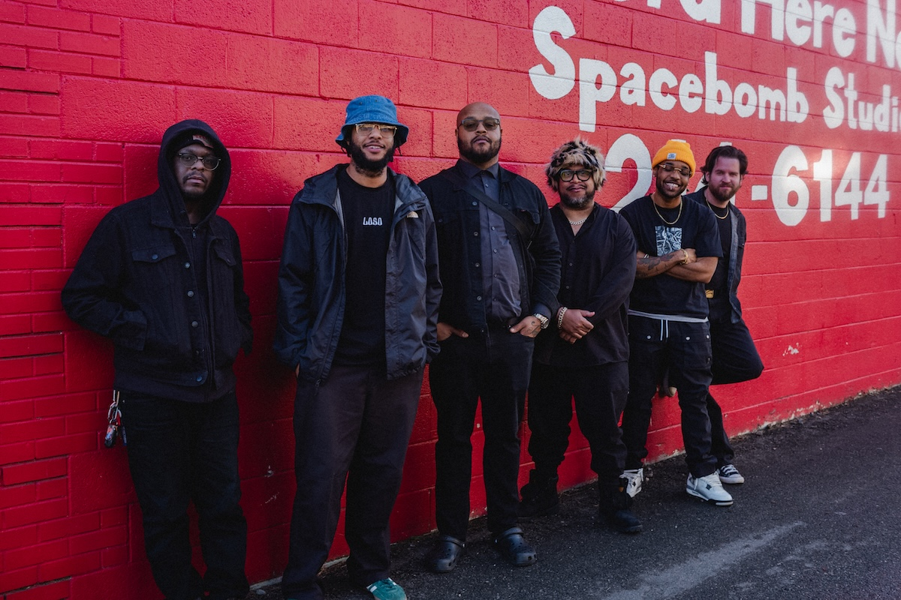
Photo credit: The Sunroom

Butcher Brown Online
Website
Spotify
Instagram
Facebook
YouTube
TikTok
X

Nicholas Payton Online
Website
Spotify
Soundcloud
YouTube
TikTok
X

Chart Room Media
brendan@chartroommedia.com | chartroommedia.com | 347-450-3048

