

FOUR-TIME GRAMMY NOMINEE + MULTI-PLATINUM SAXOPHONE ICON BONEY JAMES ANNOUNCES MILESTONE 20TH STUDIO ALBUM

A SIMPLE MAN OUT OCTOBER 2 VIA CONCORD RECORDS

SHARES NEW SINGLE + VIDEO “I BELONG TO YOU” FEAT. LEDISI

Enters His Most Personal Chapter Yet on Soulful New Collection ft Ledisi,
Marquis Hill + Larry Carlton

Tour Dates Include the Hollywood Bowl, Sony Hall + Stops in Boston, Chicago, New Orleans, Houston, more
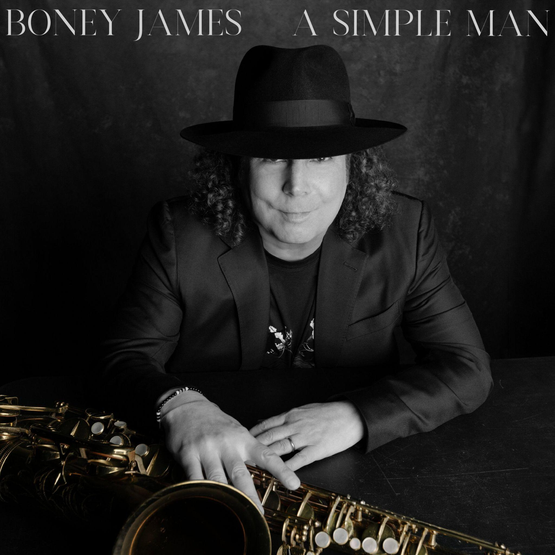
[album artwork]

August 7, 2026 // Twenty albums into a career built on deep groove and a saxophone voice all his own, Boney James is still finding new ground. Today, the four-time GRAMMY nominee and multi-platinum saxophonist, composer and producer announces new album A Simple Man, arriving October 2 via Concord Records, alongside the new single and official music video “I Belong To You” featuring Ledisi. Vinyl editions of the album will be available November 6.

A warm, contemporary R&B duet, “I Belong To You” reunites James and Ledisi more than two decades after they first appeared together on the Luther Vandross tribute album Forever, For Always, For Luther. Co-written by James and Ledisi with BeatsMadeByFresh and Rex Rideout, the song pairs her commanding vocal with the expressive tenor playing that has made James one of instrumental music’s most recognizable voices. Its intimate video keeps the focus on that exchange, moving between the two artists against a dark, minimalist backdrop.

LISTEN TO / WATCH “I BELONG TO YOU” FEAT. LEDISI HERE
PRE-ORDER / PRE-SAVE A SIMPLE MAN HERE
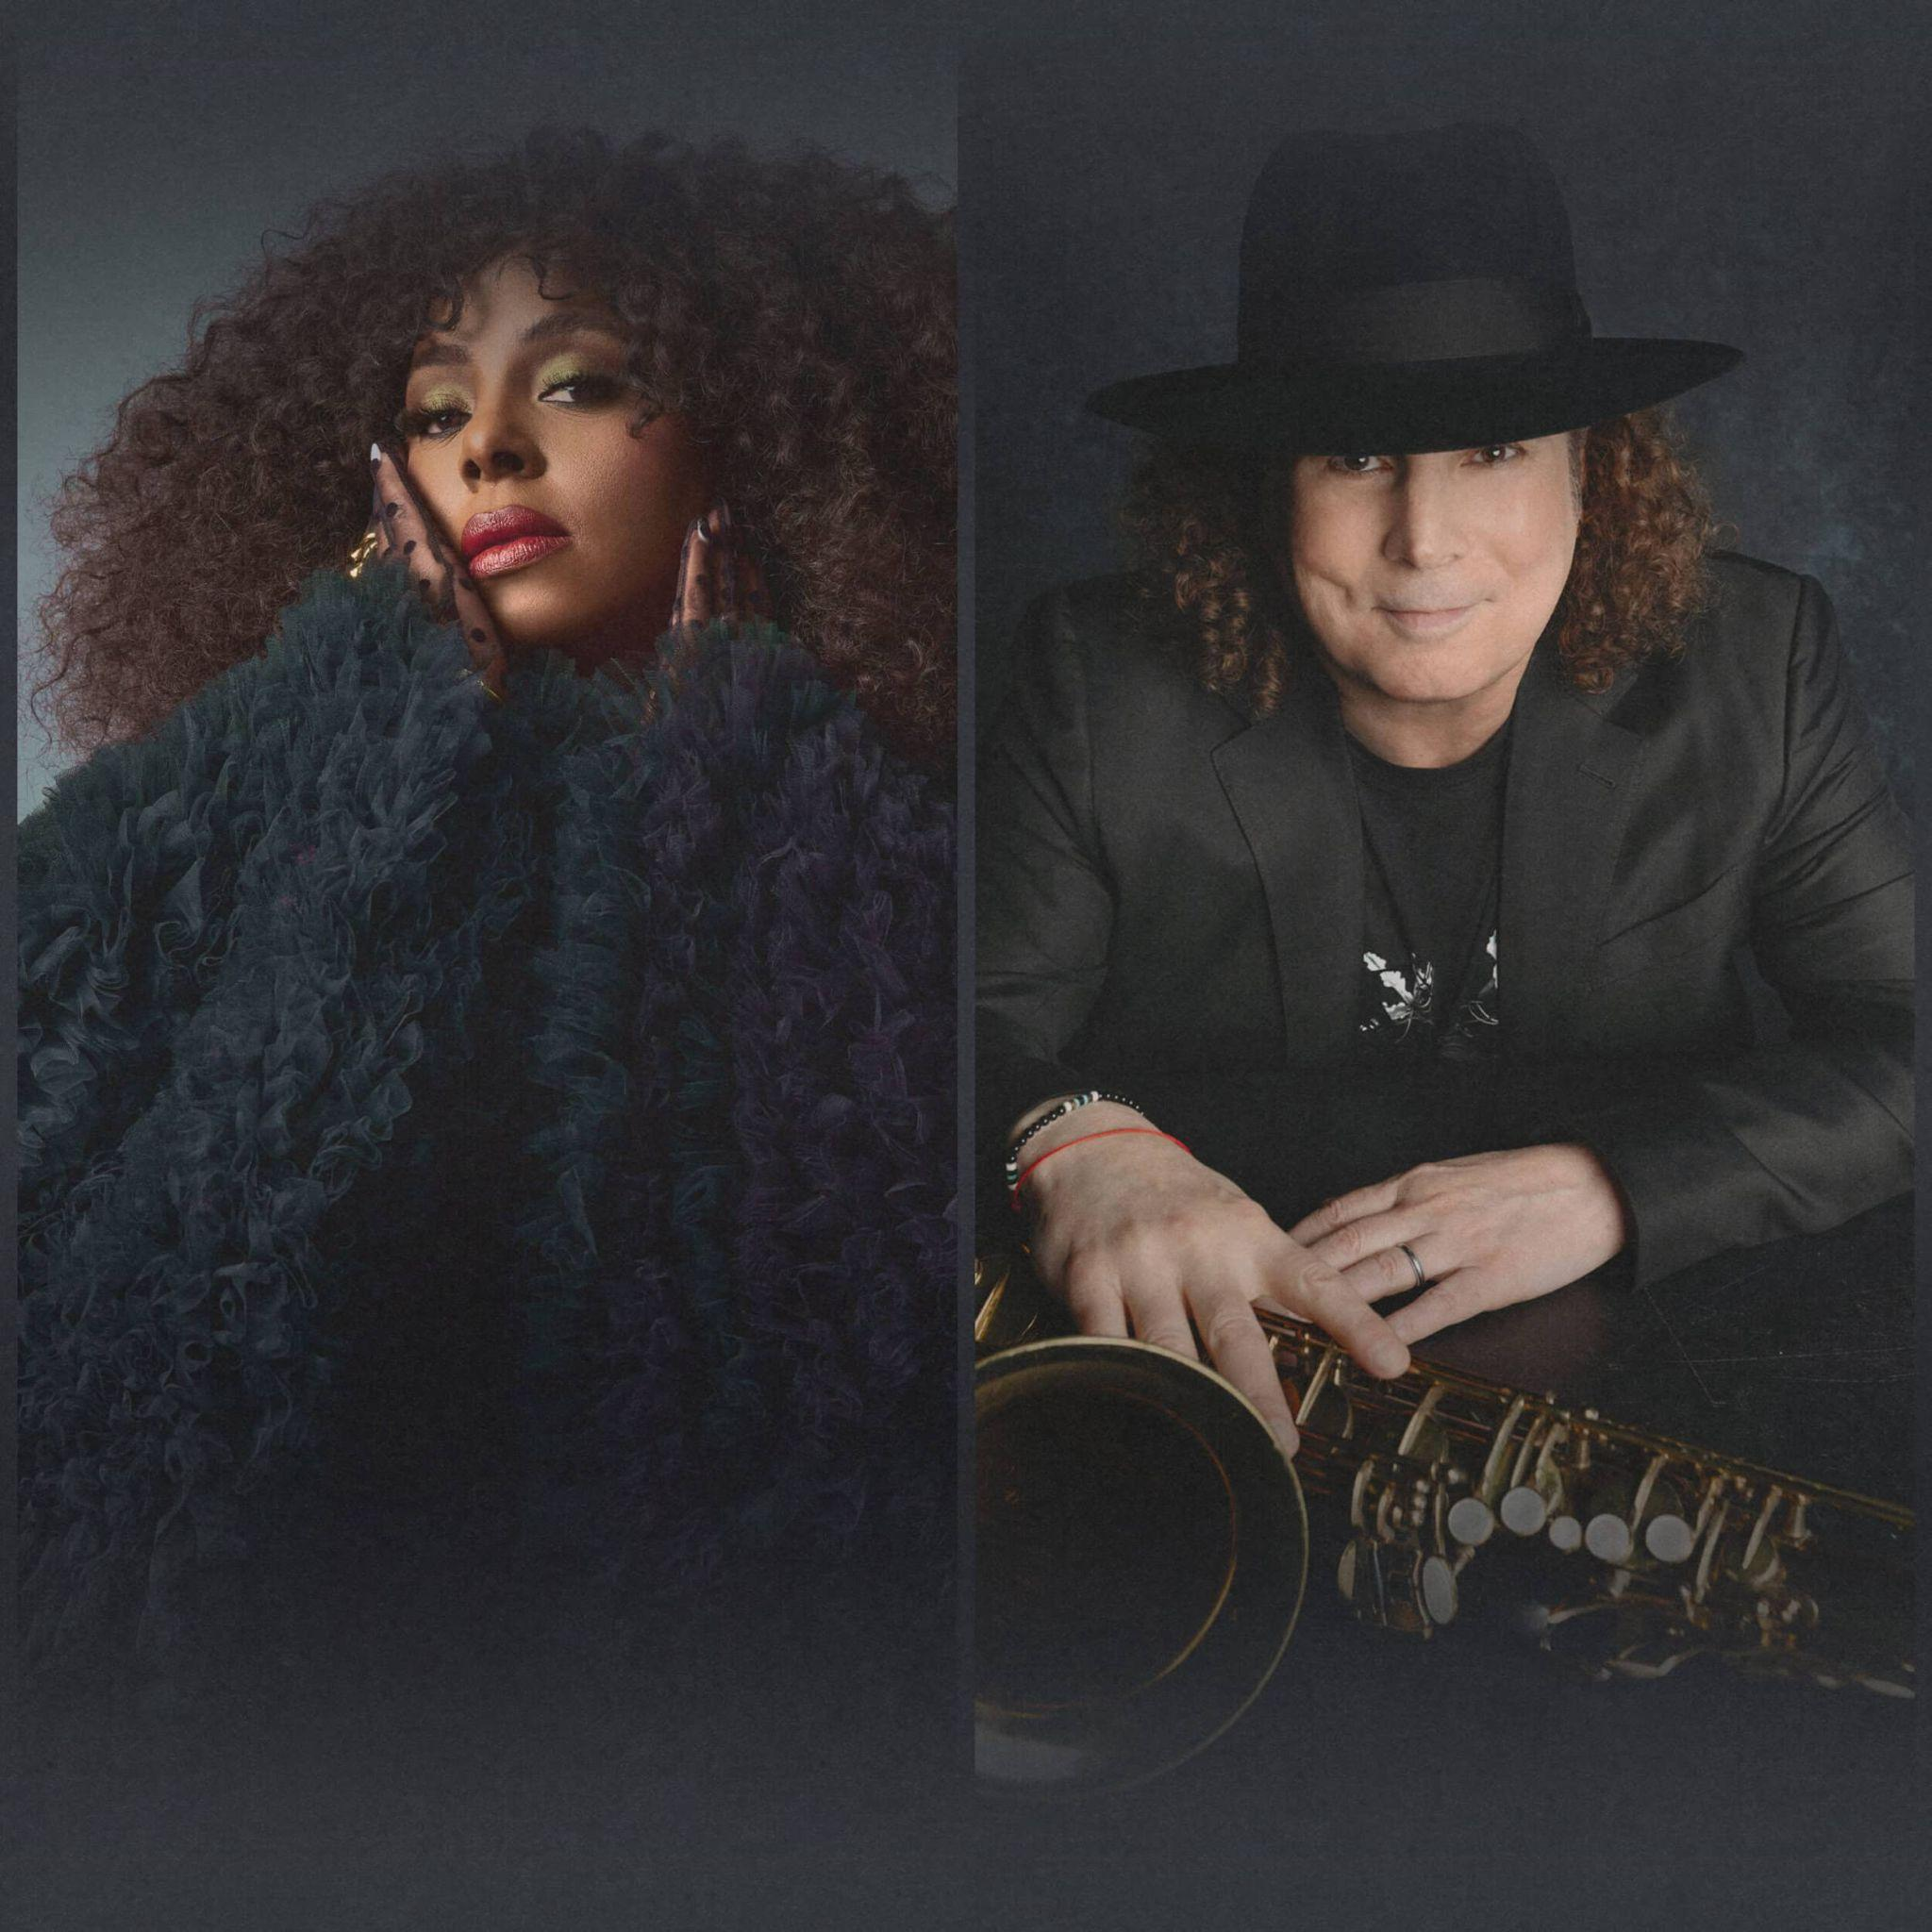
Produced by James, A Simple Man is a soulful collection shaped by his growing desire for clarity. The title began with a song, then became a reflection of how he now approaches both his work and his life: removing distraction so that the essential elements can come through more clearly. “I don’t need a lot of things to make me happy,” says James. “As I’ve gotten older, I’ve wanted to drop the extraneous things. The simple life is something I crave, and that spirit found its way into this album. A Simple Man is about getting closer to what feels essential, both in the music and in my life.”

That focus does not make the record restrained. Instead, it gives James room to move freely across the musical language he has spent decades developing, with R&B feeling at its center and jazz tradition always within reach. The album opens with “Dreams,” featuring a rare flute performance from James. “Morocco” brings him together with acclaimed trumpeter Marquis Hill for a layered meeting of live instrumentation and electronic texture. “The Midnight Sun” grew from a spontaneous soundcheck jam that James captured on his phone before rebuilding it in the studio.

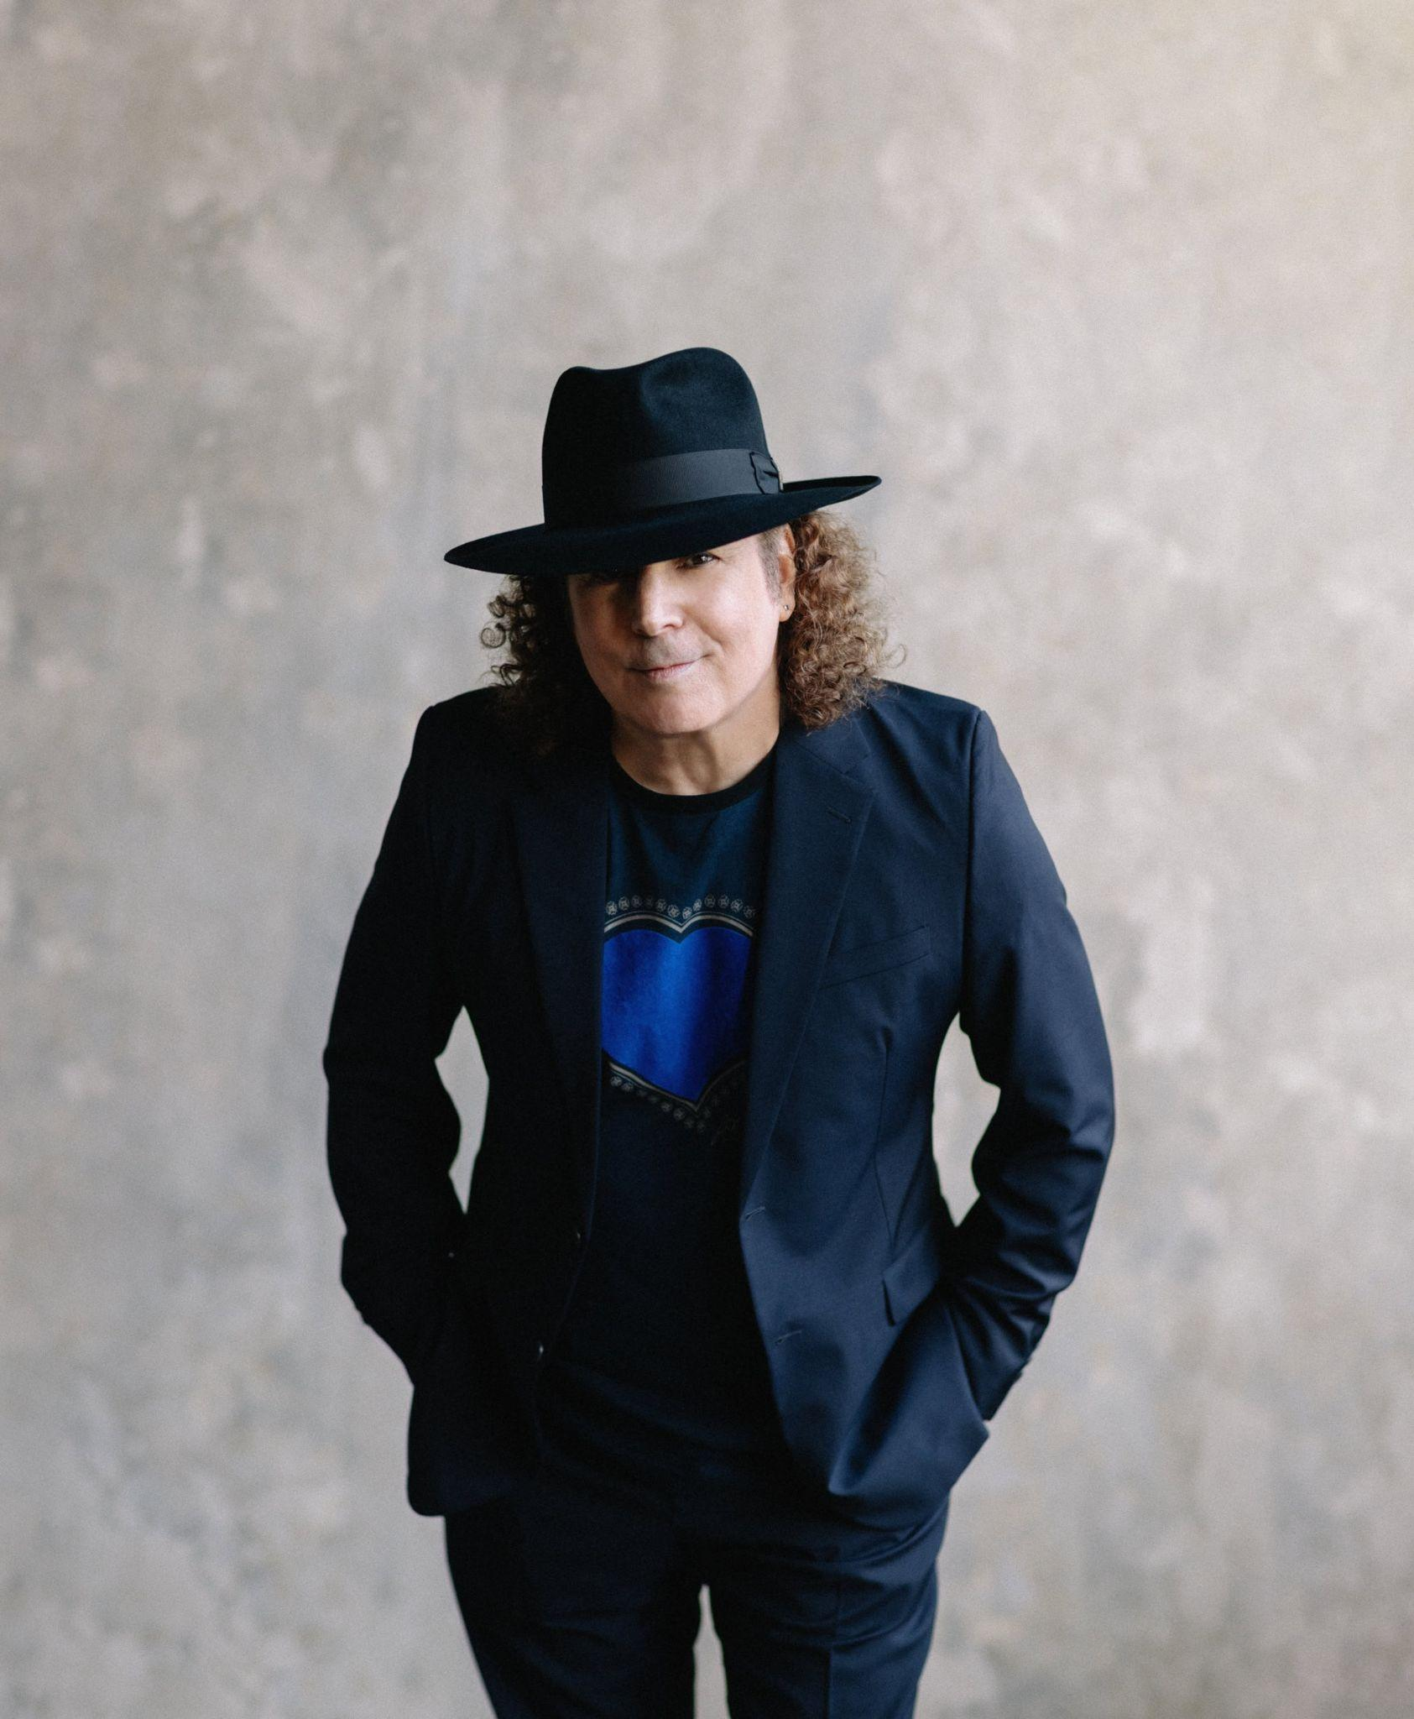
Elsewhere, “The Wire” draws from the mood of 1970s soul soundtracks. Legendary guitarist Larry Carlton joins James on the Steely Dan-influenced “Storybook,” while Duke Ellington’s “In a Sentimental Mood” is reimagined over a supple, D’Angelo-inspired groove. The hopeful “Things Are Looking Up” and the nature-minded closing track “Birdsong” give the album a sense of forward motion.

James’ path to this point began on the road. After turning professional at 19, he spent years as a sideman, first touring with Morris Day before working with The Isley Brothers, Teena Marie, Randy Crawford, Ray Parker Jr., Sheena Easton and Bobby Caldwell. Between gigs, he made demos and developed a musical identity of his own, eventually stepping forward with his 1992 debut, Trust. The decades since have brought constant touring and an expansive run of collaborations, with James recording alongside artists including George Benson, Al Jarreau, George Duke, Faith Evans, Bilal, Lalah Hathaway, Raheem DeVaughn and October London. Those relationships reflect the breadth of his sound, as well as the deep foundation in R&B that has shaped his approach from the beginning.

That long road has produced a level of longevity few artists reach. James’ catalog now spans 20 studio albums and has generated more than two billion on-demand streams in the United States, along with four million U.S. album equivalents. His honors include four GRAMMY nominations, three NAACP Image Award nominations, four RIAA Gold-certified records and a Soul Train Award. In 2024, he became the first artist to score 20 No. 1 singles on the Billboard Smooth Jazz chart. Recent vocal collaborations have also extended his reach at Adult R&B radio, where he has earned two Top 10 hits.

James is currently performing across the country. Upcoming appearances include the Hollywood Bowl and Sony Hall, followed by dates at The Fillmore New Orleans, House of Blues Houston and Yoshi’s. Full routing is below.

PRE-ORDER / PRE-SAVE A SIMPLE MAN HERE

A SIMPLE MAN TRACKLIST
Dreams
Morocco feat. Marquis Hill
The Midnight Sun
I Belong To You feat. Ledisi
Things Are Looking Up
The Wire
Storybook feat. Larry Carlton
In A Sentimental Mood
A Simple Man
Birdsong

2026 TOUR DATES
8/7 – Louisville, KY – Louisville Jazz Festival
8/8 – Cincinnati, OH – Ludlow Garage
8/9 – Cleveland Heights, OH – Cain Park, Evans Amphitheater
8/30 – Los Angeles, CA – Hollywood Bowl
9/11–9/18 – Fort Lauderdale, FL – The Smooth Jazz Cruise
9/20 – Pensacola, FL – Pensacola Community Maritime Park
10/4 – Temecula, CA – Thornton Winery
10/16 – Rehoboth Beach, DE – Rehoboth Beach Jazz Festival
10/17 – Annapolis, MD – Rams Head On Stage
10/18 – Red Bank, NJ – Vogel Theatre at the Count Basie Center
10/23 – Newport Beach, CA – Hyatt Regency Resort
10/24 – Napa, CA – Blue Note Napa Summer Sessions at Meritage Resort
10/25 – Lancaster, CA – Lancaster Performing Arts Center
10/29 – Alexandria, VA – The Birchmere
10/30 – Lansdowne, PA – Lansdowne Theater
10/31 – Boston, MA – City Winery Boston
11/1 – New York, NY – Sony Hall
11/3 – Pittsburgh, PA – City Winery Pittsburgh
11/4 – Pittsburgh, PA – City Winery Pittsburgh
11/6 – Carmel, IN – The Palladium
11/7 – Fort Wayne, IN – The Clyde Theatre
11/8 – Chesterfield, MO – The Factory
11/12 – Hampton, VA – Hampton Roads Convention Center
11/14 – Charlotte, NC – Knight Theater
11/19 – Columbus, OH – Southern Theatre
11/20 – Detroit, MI – Sound Board at MotorCity Casino Hotel
11/21 – Chicago, IL – City Winery Chicago
11/22 – Chicago, IL – City Winery Chicago
11/24 – Minneapolis, MN – Dakota
12/4 – New Orleans, LA – The Fillmore New Orleans
12/6 – Houston, TX – House of Blues
12/11 – Seattle, WA – Dimitriou’s Jazz Alley
12/12 – Seattle, WA – Dimitriou’s Jazz Alley
12/13 – Seattle, WA – Dimitriou’s Jazz Alley
12/29 – Oakland, CA – Yoshi’s
12/30 – Oakland, CA – Yoshi’s
12/31 – Oakland, CA – Yoshi’s

BONEY JAMES ONLINE
Official Website: https://boneyjames.com/
Instagram: https://www.instagram.com/boneyjames01/
Facebook: https://www.facebook.com/boneyjames
YouTube: https://www.youtube.com/user/TheRealBoneyJames
Twitter: https://x.com/boneyjames

