

FOUR-TIME GRAMMY NOMINEE + MULTI-PLATINUM SAXOPHONE ICON BONEY JAMES RECRUITS LEGENDARY GUITARIST LARRY CARLTON FOR NEW SONG + MUSIC VIDEO “STORYBOOK”

Second Taste of Milestone 20th Studio Album A Simple Man, Out October 2 via Concord Records

Co-Headlines Hollywood Bowl’s Smooth Summer Jazz with The Commodores This Sunday, August 30; Sheila E. Opens
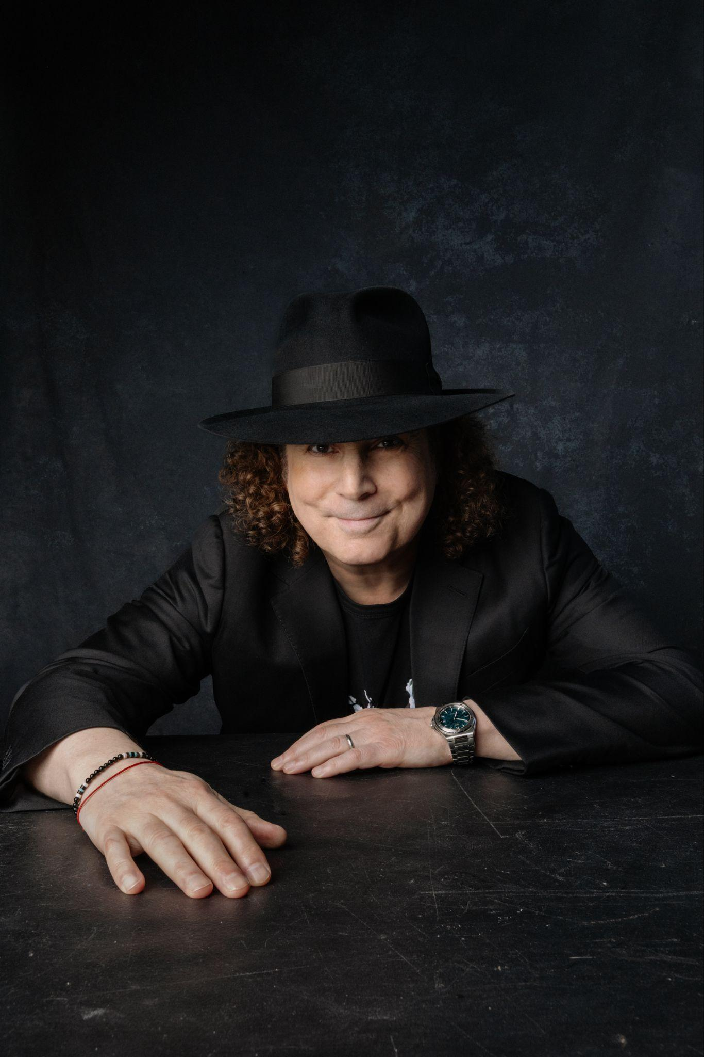
August 28, 2026 // Four-time GRAMMY nominee and multi-platinum saxophonist, composer and producer Boney James today shares “Storybook,” featuring legendary guitarist Larry Carlton. The second single from his forthcoming milestone 20th studio album, A Simple Man (out October 2 via Concord Records) arrives alongside an official music video, directed by James’s wife Lily Mariye.

The Steely Dan-influenced track lands just days before James takes the stage at the Hollywood Bowl, where he will co-headline the venue’s annual Smooth Summer Jazz celebration with The Commodores this Sunday, August 30, with Sheila E. opening the evening.

“Storybook” brings together two indisputable instrumental voices, pairing James’ warm, expressive tenor with Carlton’s singular guitar playing.

James says: “I’m so proud to feature the legendary Larry Carlton on this song. His unmistakable sound has been on so many of my favorite records, and I imagined him on ‘Storybook’ as soon as I wrote it. This song suggested a bit of mystery and whimsy to me. Hence the title, ‘Storybook.’”

LISTEN TO / WATCH “STORYBOOK” FEAT. LARRY CARLTON HERE
PRE-ORDER / PRE-SAVE A SIMPLE MAN HERE
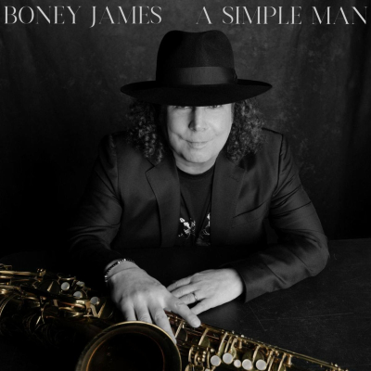

Three decades into a career built on deep groove, melodic instinct and a saxophone voice unmistakably his own, James is still finding new ground. On A Simple Man, his milestone 20th studio album, he delivers one of his most personal records yet, continuing to explore the deep connection between R&B and jazz that has shaped his music throughout his career.

James’ catalog has generated more than two billion on-demand streams in the United States. His honors include four GRAMMY nominations, three NAACP Image Award nominations, four RIAA Gold-certified records and a Soul Train Award. Billboard named him one of the Top 3 Contemporary Jazz Artists of the 2000s, and in 2024 he became the first artist to score 20 No. 1 singles on the Billboard Smooth Jazz chart. Recent collaborations have also earned him two Top 10 hits at Adult R&B.

For James, A Simple Man reflects a growing desire to strip away distraction and focus on what matters most. “As I’ve gotten older, I’ve realized I don’t need a lot to make me happy,” he says. “I love making music and playing my saxophone.”
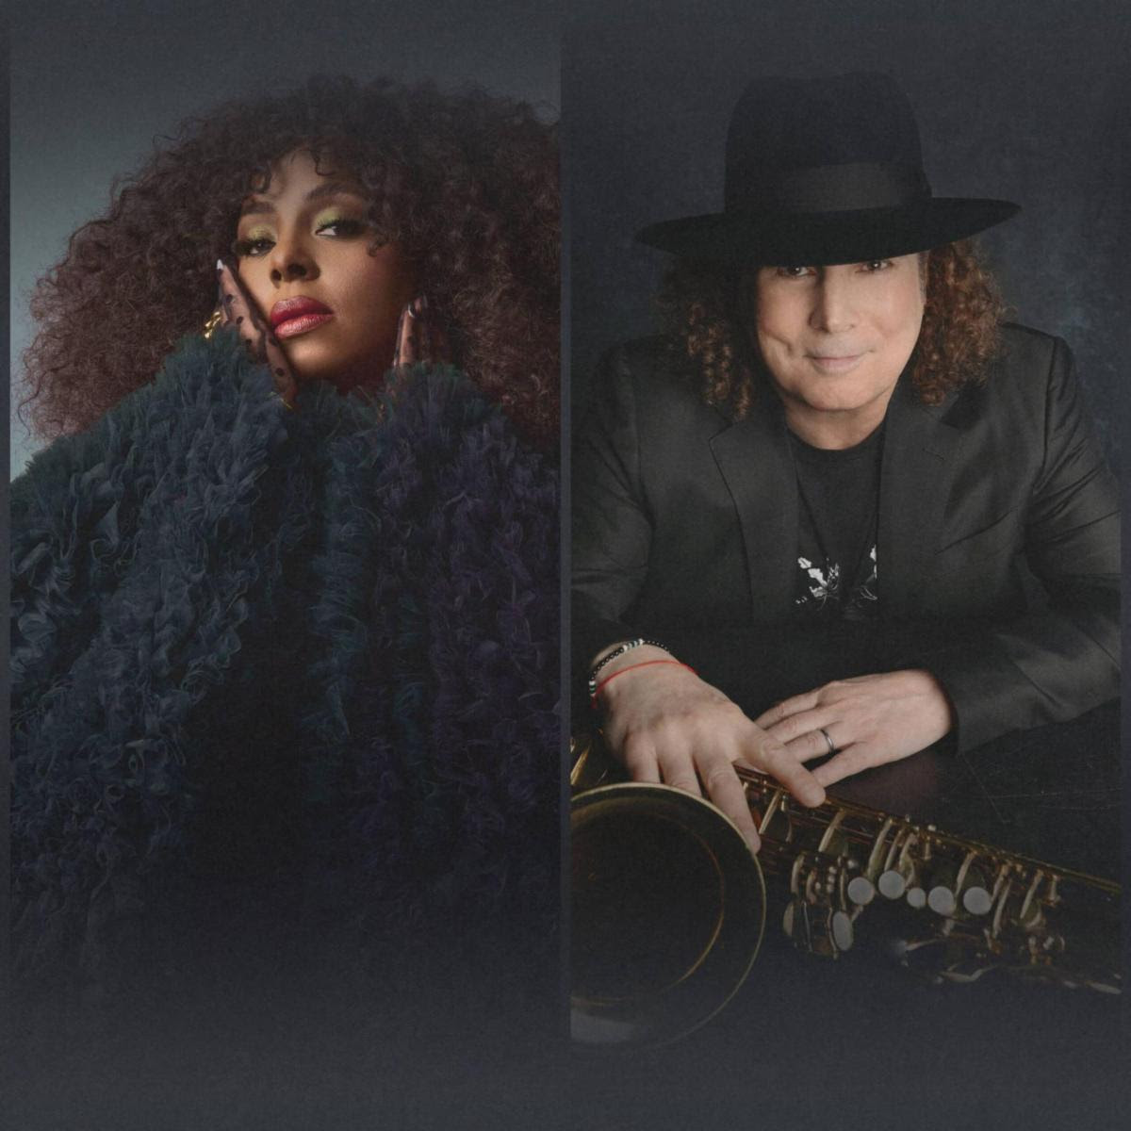
That clarity runs throughout the new album. GRAMMY-winning vocalist Ledisi joins James on the warm contemporary R&B duet “I Belong To You” and acclaimed trumpeter Marquis Hill appears on “Morocco.” James also reimagines Duke Ellington’s “In a Sentimental Mood” over a D’Angelo-inspired groove.

James’ R&B foundation runs deep. He turned professional at 19 and spent his formative years touring with Morris Day, The Isley Brothers, Teena Marie and others before stepping forward with his 1992 debut, Trust. More than three decades later, he remains focused not on preserving a legacy, but on continuing to grow. On A Simple Man, James’ playing is warmer, deeper and stronger than ever and, 20 albums in, he is still making progress.

James will bring that expansive musical history to the Hollywood Bowl this Sunday, August 30, co-headlining the venue’s annual Smooth Summer Jazz celebration alongside The Commodores, with legendary multi-instrumentalist Sheila E. opening the evening. The Hollywood Bowl appearance leads into an extensive fall run, including upcoming performances at Sony Hall in New York, The Fillmore New Orleans, House of Blues Houston, Jazz Alley in Seattle and Yoshi’s in Oakland.

James will also appear live on TalkShopLive on Tuesday, September 1 at 8:30 PM ET — his birthday — for a special conversation about A Simple Man and the new music. TUNE IN HERE

PRE-ORDER / PRE-SAVE A SIMPLE MAN HERE

A SIMPLE MAN TRACKLIST
- Dreams
- Morocco feat. Marquis Hill
- The Midnight Sun
- I Belong To You feat. Ledisi
- Things Are Looking Up
- The Wire
- Storybook feat. Larry Carlton
- In A Sentimental Mood
- A Simple Man
- Birdsong
2026 TOUR DATES
8/30 – Los Angeles, CA – Hollywood Bowl
9/11–9/18 – Fort Lauderdale, FL – The Smooth Jazz Cruise
9/20 – Pensacola, FL – Pensacola Community Maritime Park
10/4 – Temecula, CA – Thornton Winery
10/16 – Rehoboth Beach, DE – Rehoboth Beach Jazz Festival
10/17 – Annapolis, MD – Rams Head On Stage
10/18 – Red Bank, NJ – Vogel Theatre at the Count Basie Center
10/23 – Newport Beach, CA – Hyatt Regency Resort
10/24 – Napa, CA – Blue Note Napa Summer Sessions at Meritage Resort
10/25 – Lancaster, CA – Lancaster Performing Arts Center
10/29 – Alexandria, VA – The Birchmere
10/30 – Lansdowne, PA – Lansdowne Theater
10/31 – Boston, MA – City Winery Boston
11/1 – New York, NY – Sony Hall
11/3 – Pittsburgh, PA – City Winery Pittsburgh
11/4 – Pittsburgh, PA – City Winery Pittsburgh
11/6 – Carmel, IN – The Palladium
11/7 – Fort Wayne, IN – The Clyde Theatre
11/8 – Chesterfield, MO – The Factory
11/12 – Hampton, VA – Hampton Roads Convention Center
11/14 – Charlotte, NC – Knight Theater
11/19 – Columbus, OH – Southern Theatre
11/20 – Detroit, MI – Sound Board at MotorCity Casino Hotel
11/21 – Chicago, IL – City Winery Chicago
11/22 – Chicago, IL – City Winery Chicago
11/24 – Minneapolis, MN – Dakota
12/4 – New Orleans, LA – The Fillmore New Orleans
12/6 – Houston, TX – House of Blues
12/11 – Seattle, WA – Dimitriou’s Jazz Alley
12/12 – Seattle, WA – Dimitriou’s Jazz Alley
12/13 – Seattle, WA – Dimitriou’s Jazz Alley
12/29 – Oakland, CA – Yoshi’s
12/30 – Oakland, CA – Yoshi’s
12/31 – Oakland, CA – Yoshi’s

BONEY JAMES ONLINE
Official Website: https://boneyjames.com/
Instagram: https://www.instagram.com/boneyjames01/
Facebook: https://www.facebook.com/boneyjames
YouTube: https://www.youtube.com/user/TheRealBoneyJames
X: https://x.com/boneyjames

