

Keb’ Mo’ Releases New Album The Breakdown
Out Today via Concord Records

Performance Video For “They Don’t Make ‘Em Like They Used To” Out Now
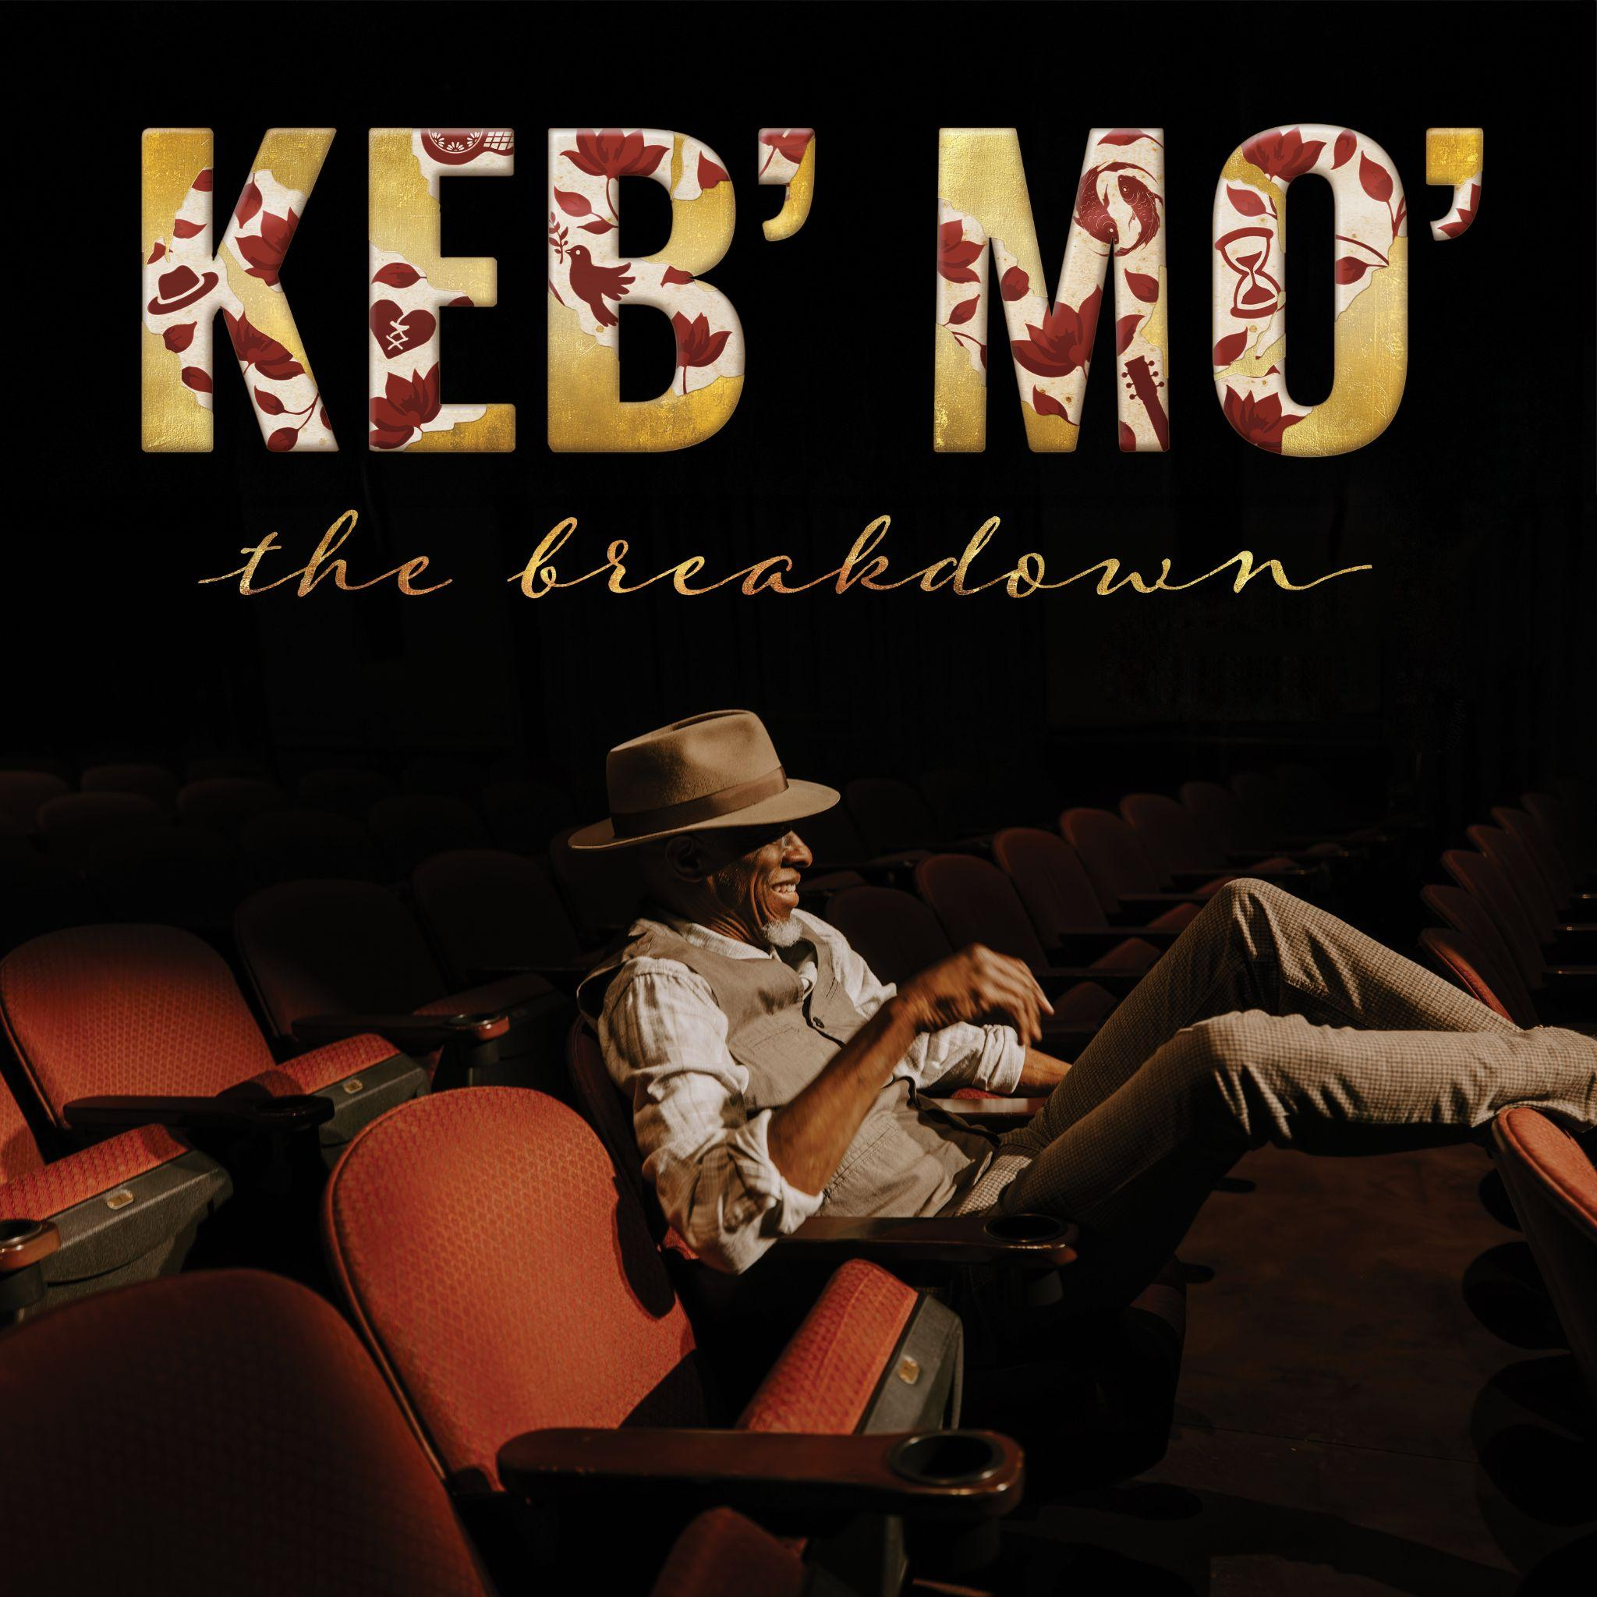
Download Album Artwork

August 21, 2026 – Today, 5x GRAMMY-winner Keb’ Mo’ released his new album The Breakdown via Concord Records. The 10-song collection is his most stripped-down and personal album to date, marking a first in his celebrated career as he pares each recording down to just his guitar, voice and carefully selected vocal contributions from the Soweto Gospel Choir and gospel sextet Take 6.

Alongside the album’s release he shared an acoustic performance video of “They Don’t Make ‘Em Like They Used To,” which features Take 6 on the album version. Today at 11:00 am CT, Keb’ Mo’ will go live on Facebook to chat about his new album.

Order/Listen to The Breakdown: https://i.concordjazz.com/kebmo_thebreakdown

The Breakdown was recorded at his home studio outside Nashville and written in the wake of life-saving open heart surgery, the end of his nearly 20-year marriage, and a period of profound personal upheaval. Stark and deeply honest, The Breakdown is Keb’ at his most revealing, grappling with the passage of time and the inevitability of change while still holding on firmly to the hope, faith, and love that have always guided him.

Americana Highways praised the “pristine” collection and proclaimed “The songs reflect stark & deeply honest themes, but his voice has no scars,” while Rock & Blues Muse said, “You may never hear a more honest and optimistic record.” Folk Alley said, “On The Breakdown Keb’ Mo’ opens his heart, revealing and working through his own struggles in spare and intimate songs that resonate emotionally with us.” Yesterday, Keb’ Mo’ appeared on the 350th episode of the Basic Folk podcast for a wide ranging conversation.

“It felt like death was tapping me on the shoulder,” Keb’ explains. “I’d been going around feeling healthy and strong all these years, and suddenly I had to face the possibility that I might not make it. I had to go through some difficult experiences to get these songs, but I learned a lot looking back on my life and my relationships and taking inventory of everything in a new light.”

That newfound perspective is front and center on The Breakdown, which manages to turn pain and uncertainty into hope and resilience at every turn. “I’m turning 75 this year,” Keb’ reflects, “and I know I won’t be around forever. All you can do is make the most of what you’ve got and be grateful for every step of the journey.”

Keb’ Mo’ will hit the road for an album release tour starting November 8 in Greenville, SC and will make stops in Chattanooga, Athens, Akron, Cincinnati and more. Find a full list of tour dates below or visit his website.

The Breakdown:
01) Fussing and Fighting
02) Every Step of the Way
03) They Don’t Make ‘Em Like They Used To (feat. Take 6)
04) More Yesterdays
05) We Make Love
06) Walking on Water
07) Hand It Over (feat. Soweto Gospel Choir)
08) Living in the Moment
09) Stitched Up Heart
10) One Day Away

Keb’ Mo’ Tour Dates:
11/08 – Greenville, SC – Peace Center Concert Hall
11/10 – Chattanooga, TN – The Walker Theatre
11/12 – Athens, GA – Hodgson Concert Hall
11/13 – Meridian, MS – Riley Center
11/14 – Marion, IL – Marion Cultural & Civic Center
11/16 – Skokie, IL – George Van Dusen Theatre at North Shore Center
11/17 – Akron, OH – Goodyear Theater
11/18 – Fort Wayne, IN – The Clyde Theatre
11/20 – Bristol, VA – Hard Rock Live Bristol
11/21 – La Grange, KY – Ashbourne Farms
11/22 – Cincinnati, OH – Hard Rock Cincinnati Ballroom
01/09 – 01/15 – Fort Lauderdale, FL – Sandy Beaches Cruise 2027
01/16 – 01/23 – Fort Lauderdale, FL – The Big Easy Cruise 2027
01/31 – 02/7 – Ft Lauderdale, FL – Legendary Rhythm and Blues Cruise
Follow Keb’ Mo’:
Website - Facebook - Instagram - Twitter
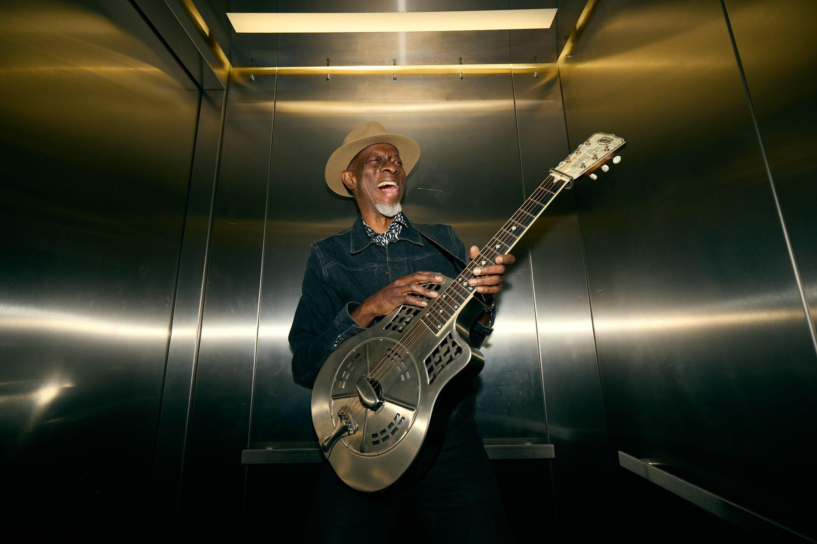
Download Photo / Credit: Rachel Deeb

For more information, please contact:
Joe Sivick (joe@missingpiecegroup.com)
Brett Loeb (brett@missingpiecegroup.com)
at Missing Piece Group

