

Keb’ Mo’ Releases New Single “One Day Away”
With Accompanying Live Video

New Album The Breakdown
out August 21 via Concord Records
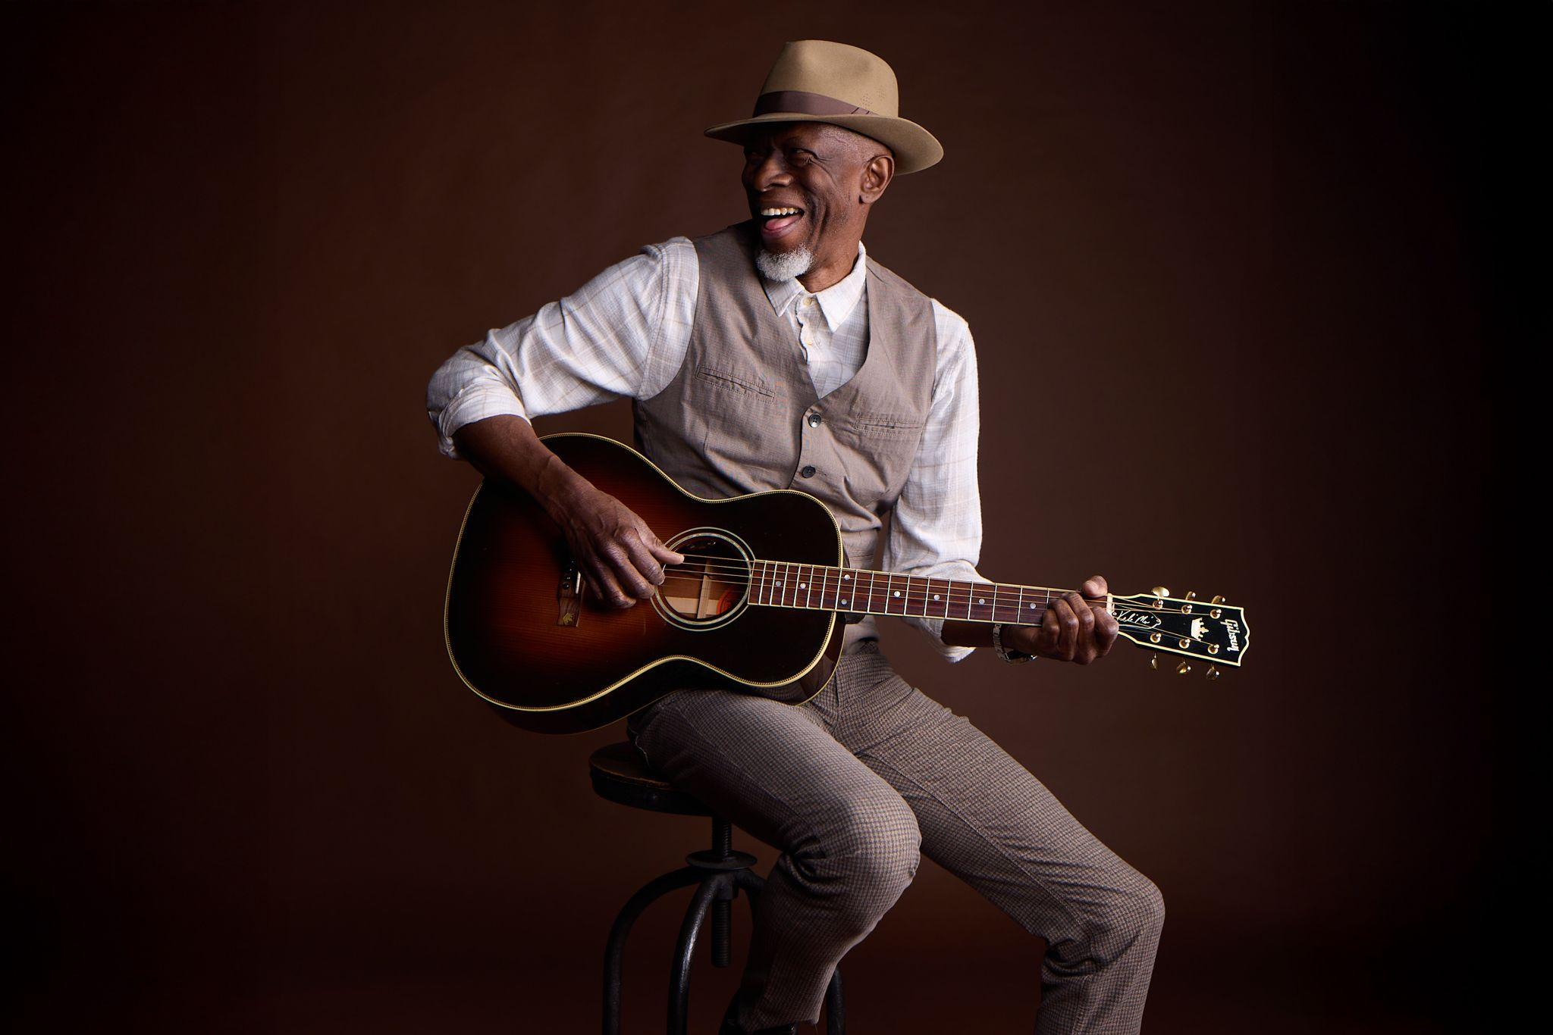
Download Photo / Credit: Rachel Deeb
July 22, 2026 – Today, 5x GRAMMY-winner Keb’ Mo’ released “One Day Away,” the newest single from his forthcoming album The Breakdown, out August 21 via Concord Records. Recorded during a period of profound personal upheaval as Keb’ recovered from a life-saving surgery, and grappled with the dissolution of his nearly 20-year marriage, the tender song reminds us that life’s best is still yet to come. The new single and accompanying live performance video follows last month’s release of “Fussing and Fighting” and “Hand It Over” featuring the Soweto Gospel Choir.
Listen to “One Day Away”
Watch the “One Day Away” Live Performance Video
Pre-order The Breakdown
About the song, Keb’ Mo’ explains: "This was the last song written for the album, and it holds a special meaning for me. It’s a reminder that life can change in an instant—that even the hardest moments can turn around, and what seems impossible today can become a blessing tomorrow."
More than 50 years into a career marked by five GRAMMY wins, an Americana Music Association Lifetime Achievement Award, performances everywhere from Carnegie Hall to The White House, and songs recorded by everyone from B.B. King to BTS, The Breakdown marks Keb’ Mo’s first solo album release since his storied career nearly came to an abrupt end in 2024. After experiencing shortness of breath on tour with Slash, Keb’ was admitted to the hospital for open heart surgery. The Breakdown was recorded at his home studio outside Nashville as he recovered from the life-saving procedure.
Stark and deeply honest, the 10-song collection is Keb’ at his most revealing, coming to terms with the passage of time and the inevitability of change while still holding on firmly to the hope, faith, and love that have always guided him. The album is also a departure for Keb’ — it’s his first ever stripped-down record featuring just his voice, guitar, and carefully selected vocal contributions from the Soweto Gospel Choir and the gospel sextet Take 6.
“I had to go through some difficult experiences to get these songs,” he confesses, “but I learned a lot looking back on my life and my relationships and taking inventory of everything in a new light.” That newfound perspective is front and center on The Breakdown, which manages to turn pain and uncertainty into hope and resilience at every turn. “I’m turning 75 this year,” Keb’ reflects, “and I know I won’t be around forever. All you can do is make the most of what you’ve got and be grateful for every step of the journey.”
The Breakdown:
01) Fussing and Fighting
02) Every Step of the Way
03) They Don’t Make ‘Em Like They Used To (feat. Take 6)
04) More Yesterdays
05) We Make Love
06) Walking on Water
07) Hand It Over (feat. Soweto Gospel Choir)
08) Living in the Moment
09) Stitched Up Heart
10) One Day Away
Keb’ Mo’ Tour Dates:
01/09 – 01/15 – Fort Lauderdale, FL – Sandy Beaches Cruise 2027 (full band)
01/16 – 01/23 – Fort Lauderdale, FL – The Big Easy Cruise 2027 (full band)
01/31 – 02/7 – Ft Lauderdale, FL – Legendary Rhythm and Blues Cruise
Follow Keb’ Mo’:
Website - Facebook - Instagram - Twitter
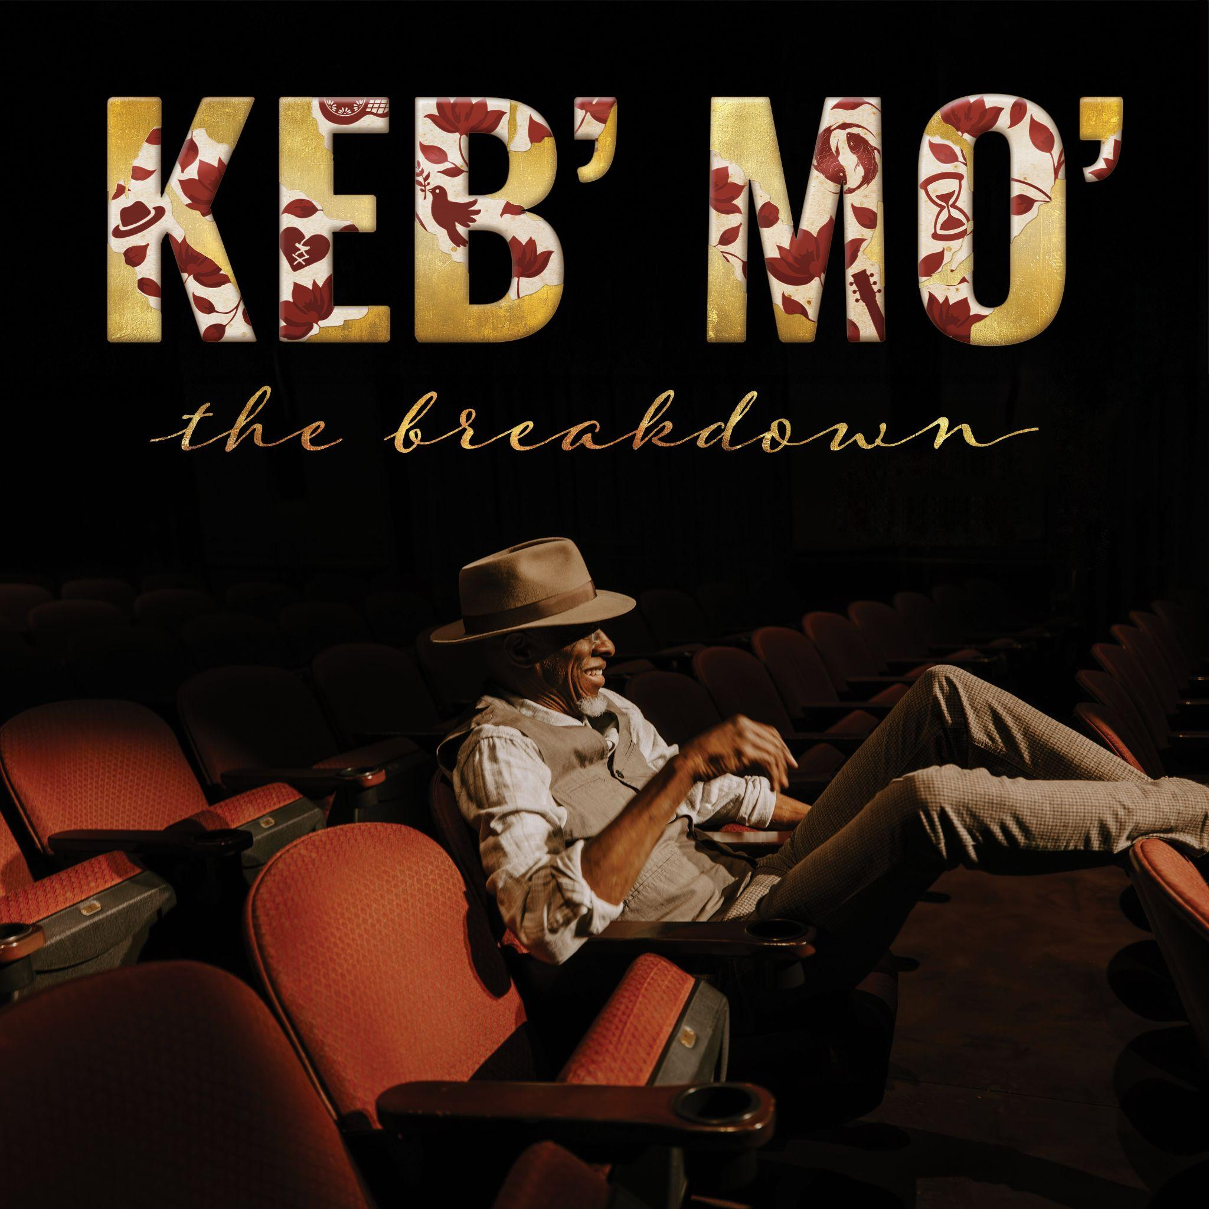
Download Album Artwork

For more information, please contact:
Joe Sivick (joe@missingpiecegroup.com)
Brett Loeb (brett@missingpiecegroup.com)
at Missing Piece Group

