

FOUR-TIME GRAMMY NOMINEE + MULTI-PLATINUM SAXOPHONIST
BONEY JAMES RELEASES MILESTONE 20TH STUDIO ALBUM
A SIMPLE MAN TODAY

Featuring Ledisi, Larry Carlton + Marquis Hill, New Collection Finds James 35+ Years Into His Career Still Following the Music Wherever It Leads

“I Belong To You” feat. Ledisi Is the #1 Gainer This Week + Top 20 at Mediabase R&B

Watch "Things Are Looking Up" Music Video HERE

Both Album-Release Shows at Blue Note Los Angeles Tonight Are SOLD OUT

LISTEN TO A SIMPLE MAN HERE
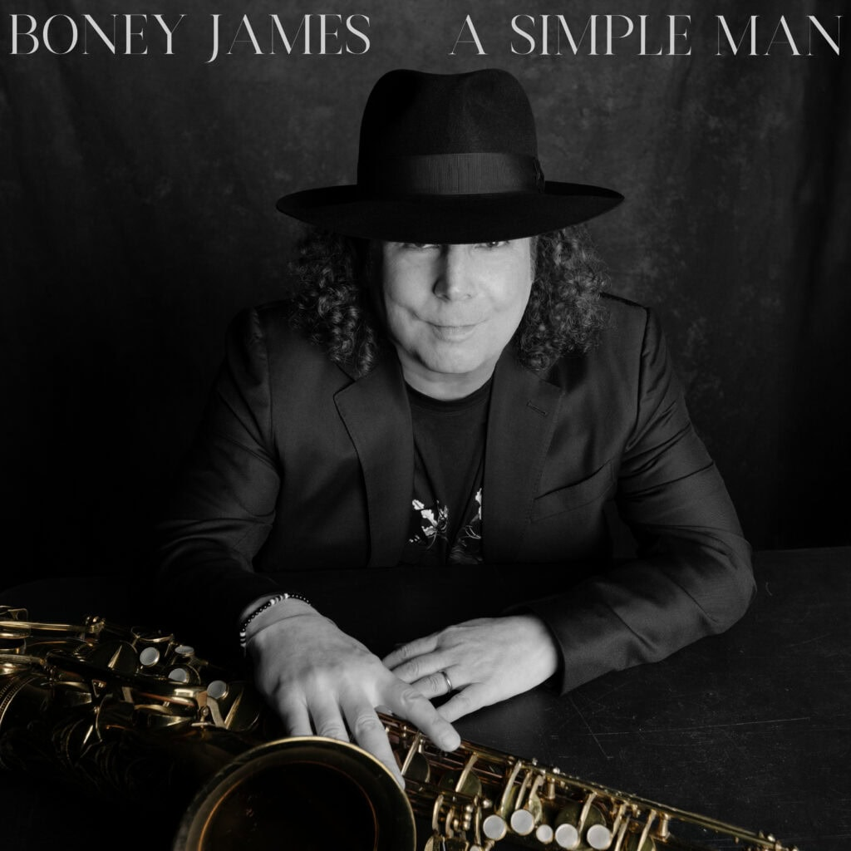
October 2, 2026 // Twenty records is enough to turn any career into a monument. Boney James has little interest in standing still long enough to become one. Today, the four-time GRAMMY-nominated, multi-platinum saxophonist, composer and producer releases A Simple Man, his 20th studio album and one of the clearest expressions yet of the musical language he has spent more than three decades developing. Out now via Concord Records, the self-produced collection brings together the deep R&B feeling and jazz-informed musicianship that have always lived at the center of James’ work, while continuing to push that vocabulary somewhere new. Vinyl editions arrive November 6.

LISTEN TO A SIMPLE MAN HERE
WATCH "THINGS ARE LOOKING UP" MUSIC VIDEO HERE

James will celebrate the release tonight at Blue Note Los Angeles, where both his 7:00pm and 9:30pm album-release shows are sold out. The homecoming follows his recent co-headlining performance at the Hollywood Bowl and comes just before an extensive fall tour takes him across the country. Full routing here and below.
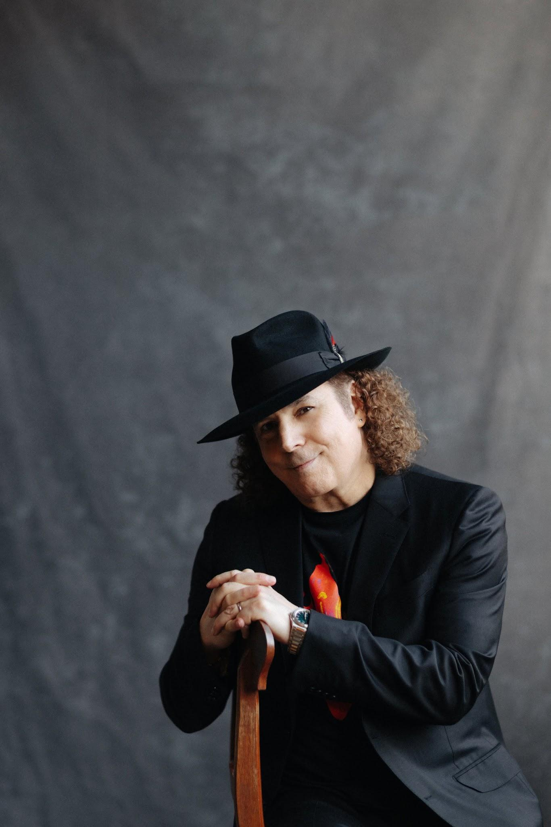
For an artist reaching a milestone as significant as album No. 20, James is strikingly uninterested in looking backward. When asked what he is still trying to prove to himself when he picks up the saxophone, his answer was simple: “I don’t think about proving anything to myself. I’m just enjoying this whole journey of music and discovery. That’s mainly what I’m thinking about: What can I learn today?” That sense of discovery runs through A Simple Man. Its title speaks less to austerity than to clarity — the process of filtering out distraction until only what matters remains. “As I’ve gotten older, I’ve wanted to drop the extraneous things,” James says. “The simple life is something I crave, and that spirit found its way into this album. A Simple Man is about getting closer to what feels essential, both in the music and in my life.”

What remains is anything but narrow. James moves through the record with the freedom of a musician who no longer feels compelled to explain where one genre ends and another begins. That instinct leads to some of the album’s most unexpected turns. On “In A Sentimental Mood,” James takes one of Duke Ellington’s most enduring compositions and hears something different beneath it: a supple groove inspired by D’Angelo. Rather than treating the standard as something fixed in amber, James lets its jazz language meet the R&B vocabulary that has shaped him since adolescence.

Elsewhere, A Simple Man opens with “Dreams,” featuring a rare flute performance from James. Acclaimed trumpeter Marquis Hill joins him on the richly textured “Morocco,” while “The Midnight Sun” traces its origins to a spontaneous soundcheck jam James captured on his phone and later rebuilt in the studio. “The Wire” draws on the cinematic atmosphere of 1970s soul, and guitar icon Larry Carlton brings his unmistakable touch to the Steely Dan-influenced “Storybook.” The hopeful “Things Are Looking Up” and nature-minded closing track “Birdsong” complete a record that prizes feel, melody and emotional directness over category.

That philosophy is perhaps clearest on “I Belong To You” featuring Ledisi, the album’s warm contemporary R&B duet and a reunion more than two decades after the two first appeared together on Forever, For Always, For Luther. The song is now Top 20 on the Mediabase R&B chart and the format’s #1 gainer this week, underscoring the connection James’ music continues to make well beyond the instrumental world.

The pairing also brings James’ lifelong relationship with the human voice into focus. Long before his solo career, he was absorbing Marvin Gaye, Stevie Wonder, Philip Bailey, Maurice White, Curtis Mayfield, Aretha Franklin and Chaka Khan, alongside saxophonists like Grover Washington Jr., Wilton Felder and Ronnie Laws. That mixture helped shape a playing style and language in which the horn functions less like an accessory than a vocalist.

James began learning that language professionally at 19, spending his formative years on the road with Morris Day before working behind The Isley Brothers, Teena Marie, Randy Crawford, Ray Parker Jr., Sheena Easton and Bobby Caldwell. He released his debut album, Trust, in 1992 and has since collaborated with artists including George Benson, Al Jarreau, George Duke, Faith Evans, Bilal, Lalah Hathaway, Raheem DeVaughn and October London.

The scale of that career is substantial: James’ catalog has generated more than two billion U.S. on-demand streams and four million U.S. album equivalents. His honors include four GRAMMY nominations, three NAACP Image Award nominations, four RIAA Gold-certified records and a Soul Train Award. Billboard named him one of the Top 3 Contemporary Jazz Artists of the 2000s, and in 2024 he became the first artist to earn 20 No. 1 singles on the Billboard Smooth Jazz chart. His recent vocal collaborations have also produced multiple Adult R&B hits.

LISTEN TO A SIMPLE MAN HERE

A SIMPLE MAN TRACKLIST
- Dreams
- Morocco feat. Marquis Hill
- The Midnight Sun
- I Belong To You feat. Ledisi
- Things Are Looking Up
- The Wire
- Storybook feat. Larry Carlton
- In A Sentimental Mood
- A Simple Man
- Birdsong
2026 TOUR DATES
8/30 – Los Angeles, CA – Hollywood Bowl
9/11–9/18 – Fort Lauderdale, FL – The Smooth Jazz Cruise
9/20 – Pensacola, FL – Pensacola Community Maritime Park
10/4 – Temecula, CA – Thornton Winery
10/16 – Rehoboth Beach, DE – Rehoboth Beach Jazz Festival
10/17 – Annapolis, MD – Rams Head On Stage
10/18 – Red Bank, NJ – Vogel Theatre at the Count Basie Center
10/23 – Newport Beach, CA – Hyatt Regency Resort
10/24 – Napa, CA – Blue Note Napa Summer Sessions at Meritage Resort
10/25 – Lancaster, CA – Lancaster Performing Arts Center
10/29 – Alexandria, VA – The Birchmere
10/30 – Lansdowne, PA – Lansdowne Theater
10/31 – Boston, MA – City Winery Boston
11/1 – New York, NY – Sony Hall
11/3 – Pittsburgh, PA – City Winery Pittsburgh
11/4 – Pittsburgh, PA – City Winery Pittsburgh
11/6 – Carmel, IN – The Palladium
11/7 – Fort Wayne, IN – The Clyde Theatre
11/8 – Chesterfield, MO – The Factory
11/12 – Hampton, VA – Hampton Roads Convention Center
11/14 – Charlotte, NC – Knight Theater
11/19 – Columbus, OH – Southern Theatre
11/20 – Detroit, MI – Sound Board at MotorCity Casino Hotel
11/21 – Chicago, IL – City Winery Chicago
11/22 – Chicago, IL – City Winery Chicago
11/24 – Minneapolis, MN – Dakota
12/4 – New Orleans, LA – The Fillmore New Orleans
12/6 – Houston, TX – House of Blues
12/11 – Seattle, WA – Dimitriou’s Jazz Alley
12/12 – Seattle, WA – Dimitriou’s Jazz Alley
12/13 – Seattle, WA – Dimitriou’s Jazz Alley
12/29 – Oakland, CA – Yoshi’s
12/30 – Oakland, CA – Yoshi’s
12/31 – Oakland, CA – Yoshi’s

BONEY JAMES ONLINE
Official Website: https://boneyjames.com/
Instagram: https://www.instagram.com/boneyjames01/
Facebook: https://www.facebook.com/boneyjames
YouTube: https://www.youtube.com/user/TheRealBoneyJames
X: https://x.com/boneyjames

